Illustrative Documents
American Communists and Soviet Espionage
in the Early Cold War: Revelations from the Archives
by John Earl Haynes

Part 1
American Communism and the
Communist International in Moscow
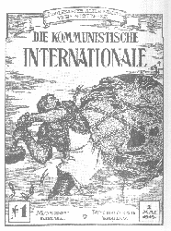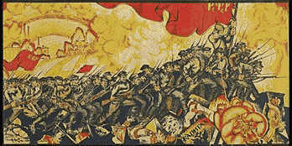

**********************************************

Part 2
American Communism and Soviet Espionage
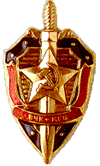
[The sword-and-shield emblem of the KGB]
Illustrative Documents
American Communists and Soviet Espionage in the Early Cold War:
Revelations from the Archives

Part 1 Introduction
American Communism and the Communist International in Moscow

Documents

1. First and last page of 21 page application (24 November 1919) by the Communist Party of America for admission to the Communist International (Comintern). RGASPI Moscow 515-1-9

2. First and third pages of "Parliamentarism, Soviet Power and the Creation of a Communist Party of America," statement of the Communist International on the tasks the Communist Party of America. RGASPI Moscow 515-1-1

3. Application for Membership to the Communist Party USA, 1936, including "adherence to the program and statues of the Communist International." RGASPI Moscow 515-1-4014

4. Letter, 1924, from Ruthenberg (executive secretary of the CPUSA) to Amter (CPUSA representative in Moscow) on the issues the CPUSA wants the Comintern to decide. RGASPI Moscow 515-1-307

5. Comintern to CPUSA cable instructing the CPUSA to drastically change its position on the 1924 American presidential election. RGASPI Moscow 515-1-255

6. Letter (transcription), 1938, from CPUSA representative in Moscow to Dimitrov of the Comintern acknowledging that the CPUSA will, in accordance with Comintern instructions, drop its slogan "Communism is Twentieth Century Americanism." RGASPI Moscow 495-74-466

7. Comintern cable, 1936, instructing the CPUSA to change its proposed slate of members of the Political Bureau, the party’s top executive officers. RGASPI Moscow 515-1-3961

8. Transcription and translation of the January 1945 cover of the secret Bulletin of the Information Bureau of the Communist Party of the Soviet Union listing an essay on the CPUSA, prepared by the CPSU that later appeared in the French Communist journal Les Cahiers du communisme in April 1945 with the by-line of Jacques Duclos RGASPI Moscow 17-128-754.

9. Translation of part of a report, 1947, by the International Department of the CPSU regarding questions raised by Morris Childs (CPUSA representative) about which the CPUSA wanted CPSU guidance. The first question dealt with was whether the CPUSA should support creation of a third party in the 1948 American presidential election. RGASPI Moscow 17-128-1128

10. Transcription of part of the minutes of a Comintern Anglo-American Secretariat meeting, 1935, on the CPUSA dealing with the former CPUSA official Lovett Fort-Whiteman, then resident in Moscow. RGASPI Moscow 495-14-1

11. Death certificate, 1938, for Lovett Fort-Whiteman, American Communist, Sevvostlag labor camp, Siberia, USSR, with translation and death fingerprints. State Archive of the Russian Federation, Moscow.
11a. Original Record
11b. Translation
11c. Fingerprints

12. Arrest certificate, Moscow, 1938, for Thomas Sgovio, American Communist, along with three Sgovio GULAG drawings. State Archive of the Russian Federation and Sgovio papers
12a Original Record
12b. Translation
12c. Sgovio prison photo
12d. “Winter Work”
12e. “Frost-Bite”
12f. “Archive Nº Three”

13. Finnish-American victims of the Great Terror.
13a. Photograph of memorial to the three murdered Finnish-American directors of the Soviet Karelian Technical Aid Committee at Sandarmokh KGB burial site.
13b. Names, biographical data, and dates of execution of 141 Finnish Americans buried in a secret KGB mass grave at Sandarmokh in Russian Karelia.

14. First page of Comintern accounting sheet of subsidies, in currency and in valuables (gold, jewels), delivered in 1919 and 1920 to newly formed Communist parties in Europe and the United States. RGASPI Moscow 495-82-1
14a. Original record
14b. Translation

15. Deciphered telegram from the American Communist Party to the Comintern, 1925, complaining of the slow delivery of secret Comintern subsidies by Armand Hammer. RGASPI Moscow 515-1-422 (I)

16. First page of accounting sheet by the Communist Party of the Soviet Union for subsidies provided to foreign Communist parties in 1973. Volkogonov Papers (Library of Congress), box 24, original from the Archive of the President of the Russian Federation
16a. Original record
16b. Translation

17. First page of a six page 1929 report by a CPUSA labor organizer on his attempt to get striking white textile workers in Gastonia, North Carolina, to actively include black workers in the strike. RGASPI Moscow 515-1-1662

18. Two pages from an eighteen-page report by a CPUSA representative to the Comintern, 1936, on the work of the CPUSA in the newly organized Congress of Industrial Organizations (CIO). RGASPI Moscow 515-1-3967a RGASPI Moscow 515-1-3967b
18a. page 1 of report
18b. page 17 of report

19. Comintern biographical sketches of members of the CPUSA central committee in 1938, including secret members giving both pseudonyms and real names, including that of Harry Bridges, head of the International Longshoremen’s and Warehousemen’s Union (ILWU), RGASPI Moscow 495-74-467
19a. Original document
19b. Translation of section on Bridges

20. First page of minutes of CPUSA District Bureau of CPUSA regional District #7 (Detroit and Michigan) for February 19, 1936 regarding the CPUSA stance and tactics toward effort to organize a new national third party (the "Labor Party Question"). RGASPI Moscow 515-1-4015

21. First page of internal CPUSA Political Bureau Report praising President Roosevelt's January 1939 address to the U.S. Congress in which FDR called for international resistance to fascist aggression and increased American defense preparation. RGASPI Moscow 495-14-117

22. Part of Dimitrov (Comintern) to Browder (CPUSA) coded message correcting CPUSA interpretation of the Nazi-Soviet Pact of September 1939. RGASPI Moscow 495-74-469

23. Page from 85 page internal CPUSA report to Moscow, 1941, on the CPUSA's political stance opposing President Roosevelt's program of providing military assistance to Great Britain and other nations fighting Nazi Germany. RGASPI Moscow 515-1-4091
******************************************************************************

Illustrative Documents
American Communists and Soviet Espionage in the Early Cold War:
Revelations from the Archives

Part 2
American Communism and Soviet Espionage
“March of the Dzerzhinskians”

[The sword-and-shield emblem of the KGB]

Documents

24. Excerpts copied by a CPUSA source in the U.S. State Department from confidential correspondence between the U.S. Ambassador to France and the Assistant Secretary of State. The material, from the late fall of 1936, is marked as reaching Moscow in January of 1937. RGASPI Moscow 515-1-4077

25. Browder to Dimitrov letter, 1938, on his sister’s work for Soviet intelligence. KGB archive.

26. Translation of a 1940 cover note of Beria (KGB) to Dimitrov (Comintern) transmitting a message from Browder (CPUSA) conveying an offer of service to the USSR from a leading French politician then in exile. RGASPI Moscow 495-74-478

27. Decrypted message (cablegram), 1942, Moscow KGB headquarter to New York KGB station regarding the "signing on" of Pierre Cot. NSA Venona Project Records

28. Decrypted message, New York KGB station to Moscow Headquarters, 1944, regarding Elizabeth Bentley and the large CPUSA-based espionage apparatus headed by Victor Perlo. NSA Venona Project Records

29. Translation of Fitin (KGB) to Dimitrov (Comintern) message, 1944, regarding members of the Perlo apparatus. RGASPI Moscow 495-74-485

30. Excerpt from Venona 1433-1435 New York KGB station to Moscow KGB headquarters, 10 October 1944, discussing the extent of KGB dependence on CPUSA assistance for its espionage operations in the U.S. NSA Venona Project Records

31. Decrypted message, New York KGB station to Moscow Headquarters, Venona 1557, 27 November 1944, regarding Julius and Ethel Rosenberg and Joel Barr, a major source of Rosenberg’s network. NSA Venona Project Records

32. Two parts of a lengthy decrypted message Venona 1119 1121 KGB New York to Moscow, 4-5 August 1944. KGB officer report on meeting with Harry White, Assistant Secretary of the Treasury, and White’s willingness to assist the KGB despite the risks. NSA Venona Project Records.
32a. first part
33b. second part

34. Decrypted message, Venona 1585 KGB New York to Moscow, 12 November 1944. Meeting of KGB agent with Harvard physicist Theodore Hall and Hall’s willingness to assist the KGB by reporting on his work at Los Alamos. NSA Venona Project Records

35. Decrypted message, Venona 1822 KGB Washington to KGB Moscow, 30 March 1945, on meeting of KGB officer with a GRU source, Ales (Alger Hiss). NSA Venona Project Records

36. Former KGB officer Alexander Vassiliev’s notes, handwritten in Russian taken from records in the KGB archive on the December 1948 Anatoly Gorsky memo on compromised Soviet sources in the United States, 1938-1948, with translation. Papers of Alexander Vassiliev

*****************************************************************************

American Communists and Soviet Espionage in the Early Cold War: Revelations from the Archives

Part 1
American Communism and the Communist International in Moscow

The Internationale (Soviet version)
The “New Singers,” 1933?-1935?, with Marc Blitzstein,
Broadway Musical Composer and Communist, on piano

Arise, you prisoners of starvation. Arise, you wretched of the earth
For justice thunders condemnation, for a better world's in birth.
No more tradition's chains shall bind us. Arise you slaves, no more in thrall.
The earth shall rise on new foundation: we have been naught, we shall be all.
'Tis the final conflict, let each stand in his place.
The International Soviet shall be the human race. (repeat)
We want no condescending saviors to rule us from a judgment hall
We workers ask not for their favors, let us consult for all.
To make the thief disgorge his booty, to free the spirit from your cell
We must ourselves decide our duty, we must decide and do it well.
'Tis the final conflict, let each stand in his place.
The International Soviet shall be the human race. (repeat)

Document 1
First (part) and last page of 21-page application (24 November 1919) by the Communist Party of America for admission to the Communist International (Comintern). RGASPI Moscow 515-1-9
************************************************************************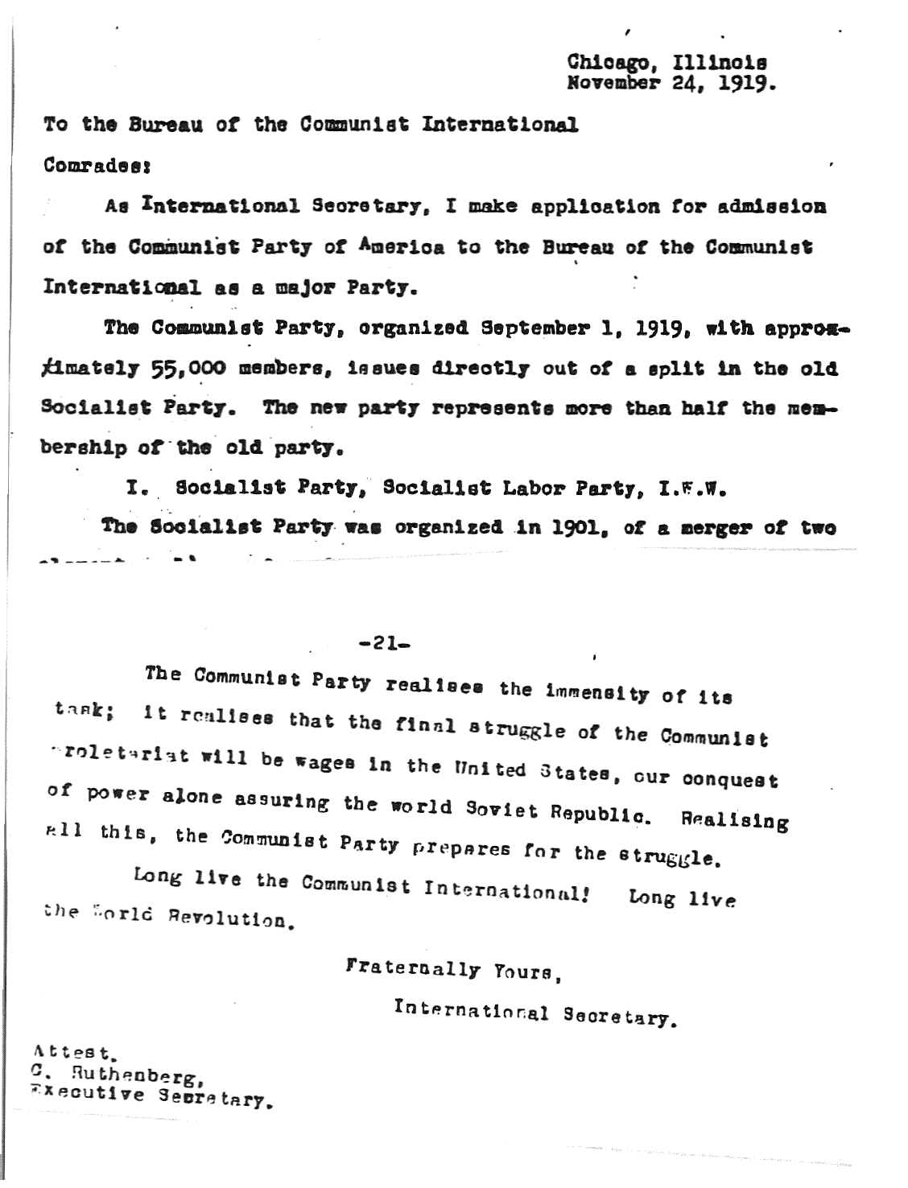
Document 2
First and third pages of "Parliamentarism, Soviet Power and the Creation of a Communist Party of America," Comintern statement, tasks of the CPA, RGASPI Moscow 515-1-1
******************************************************************
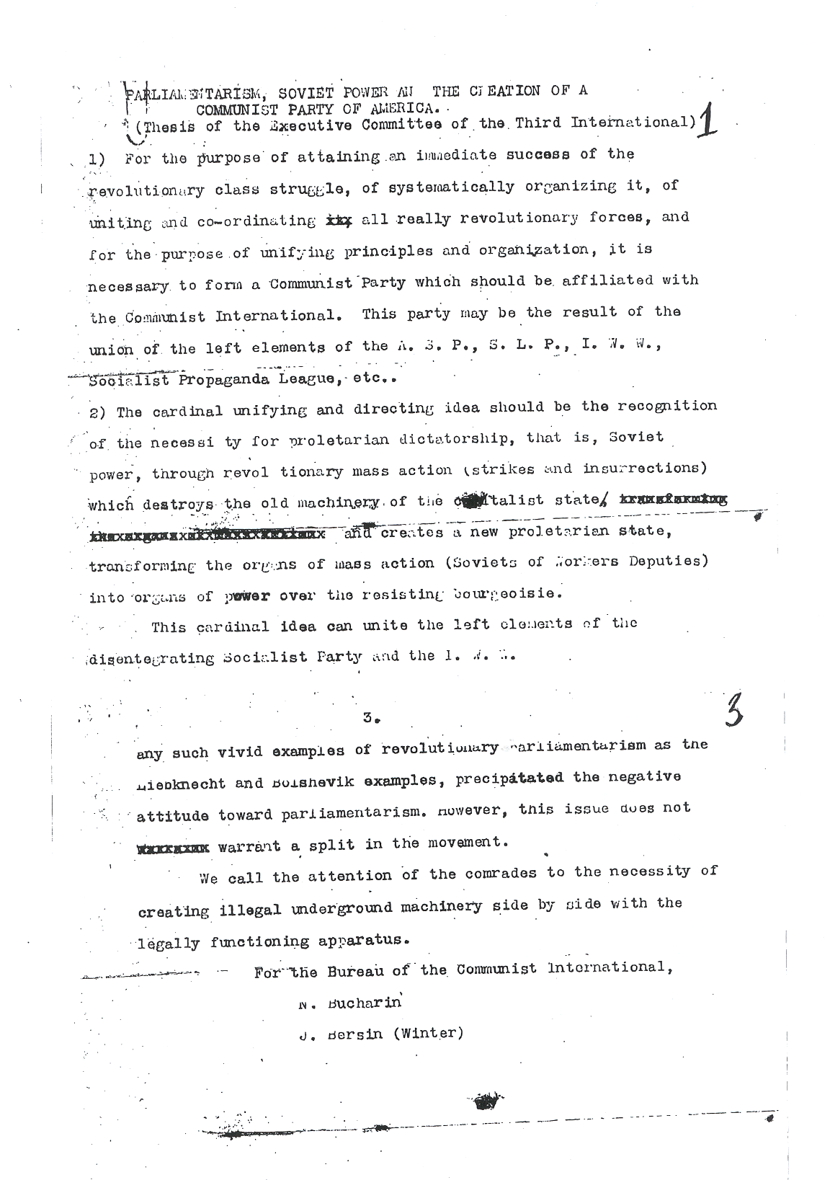
Document 3
Application for Membership to the Communist Party USA, 1936, including "adherence to the program and statues of the Communist International." RGASPI Moscow 515-1-4014
************************************************************************

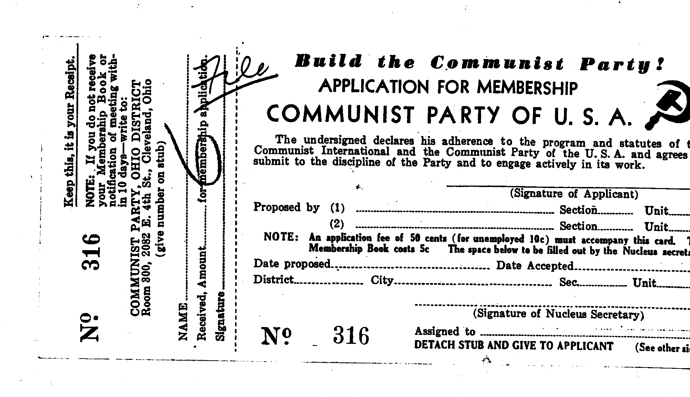
Document 4
Letter, 1924, American C.P. to its Moscow representative on the policy issues the American C.P. wanted the Comintern to decide. RGASPI Moscow 515-1-307
*********************************************************************
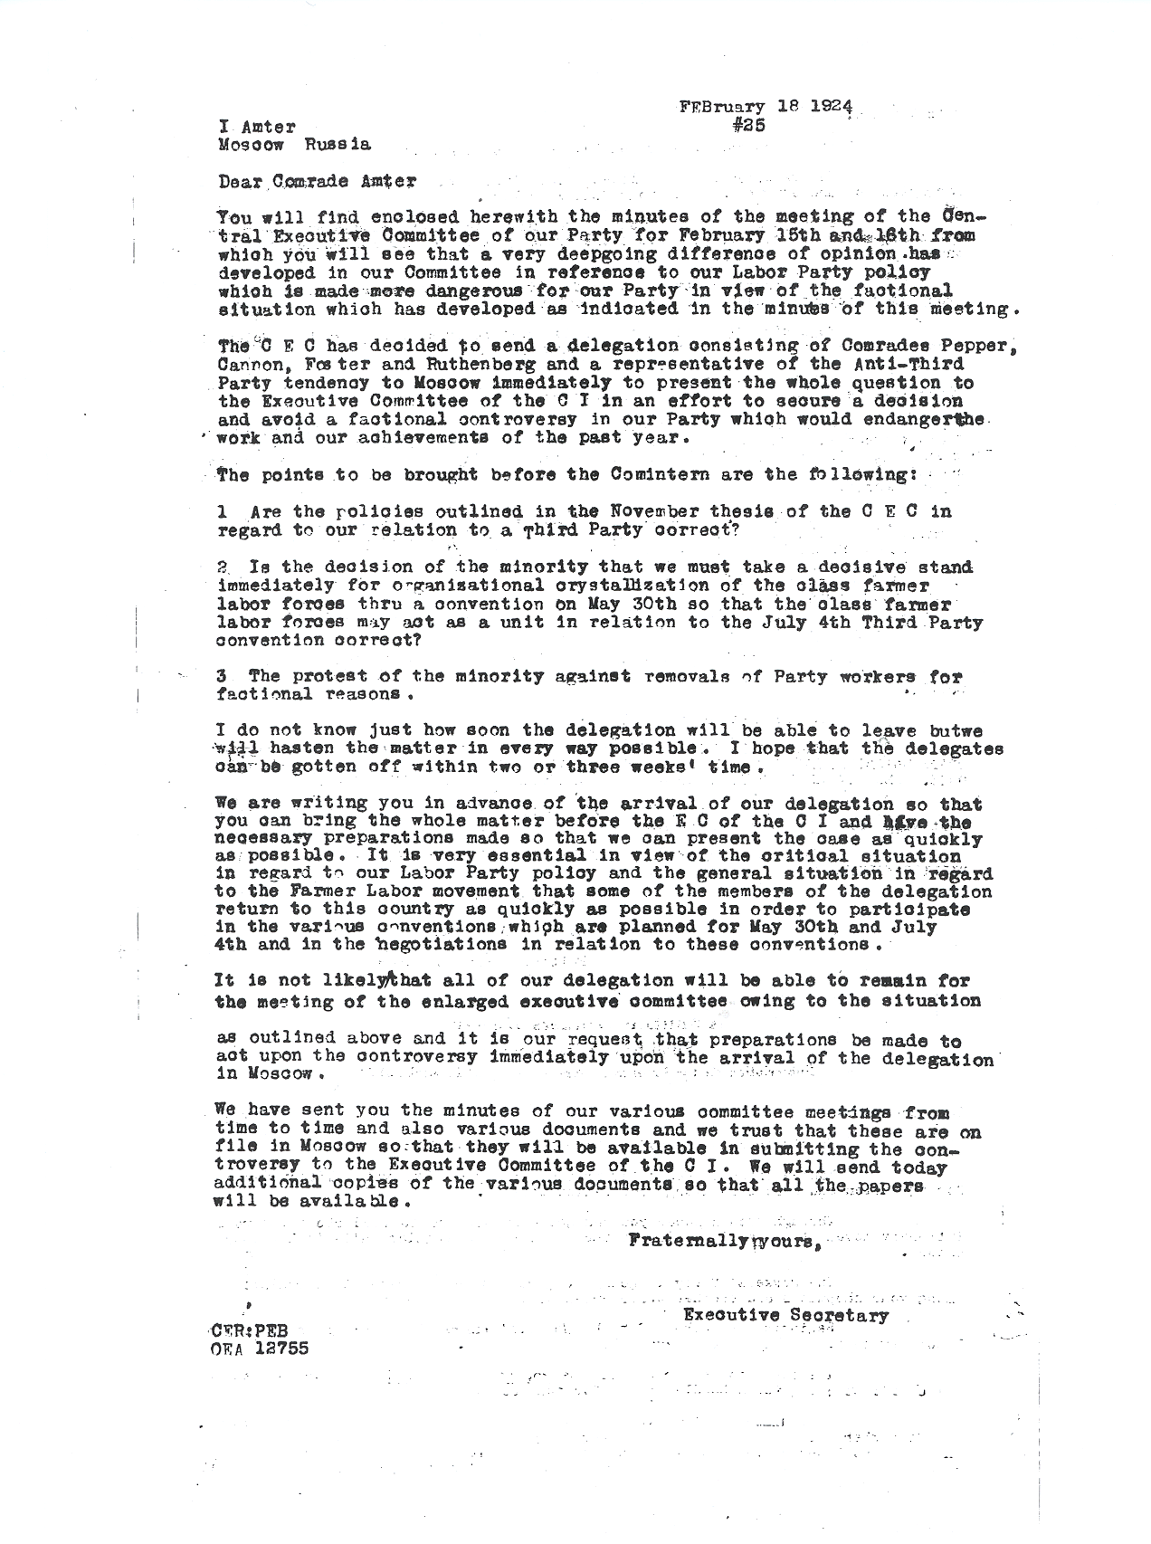

Document 5
Comintern to CPUSA cable instructing the CPUSA to drastically change its position on the 1924 American presidential election. RGASPI Moscow 515-1-255
********************************************************************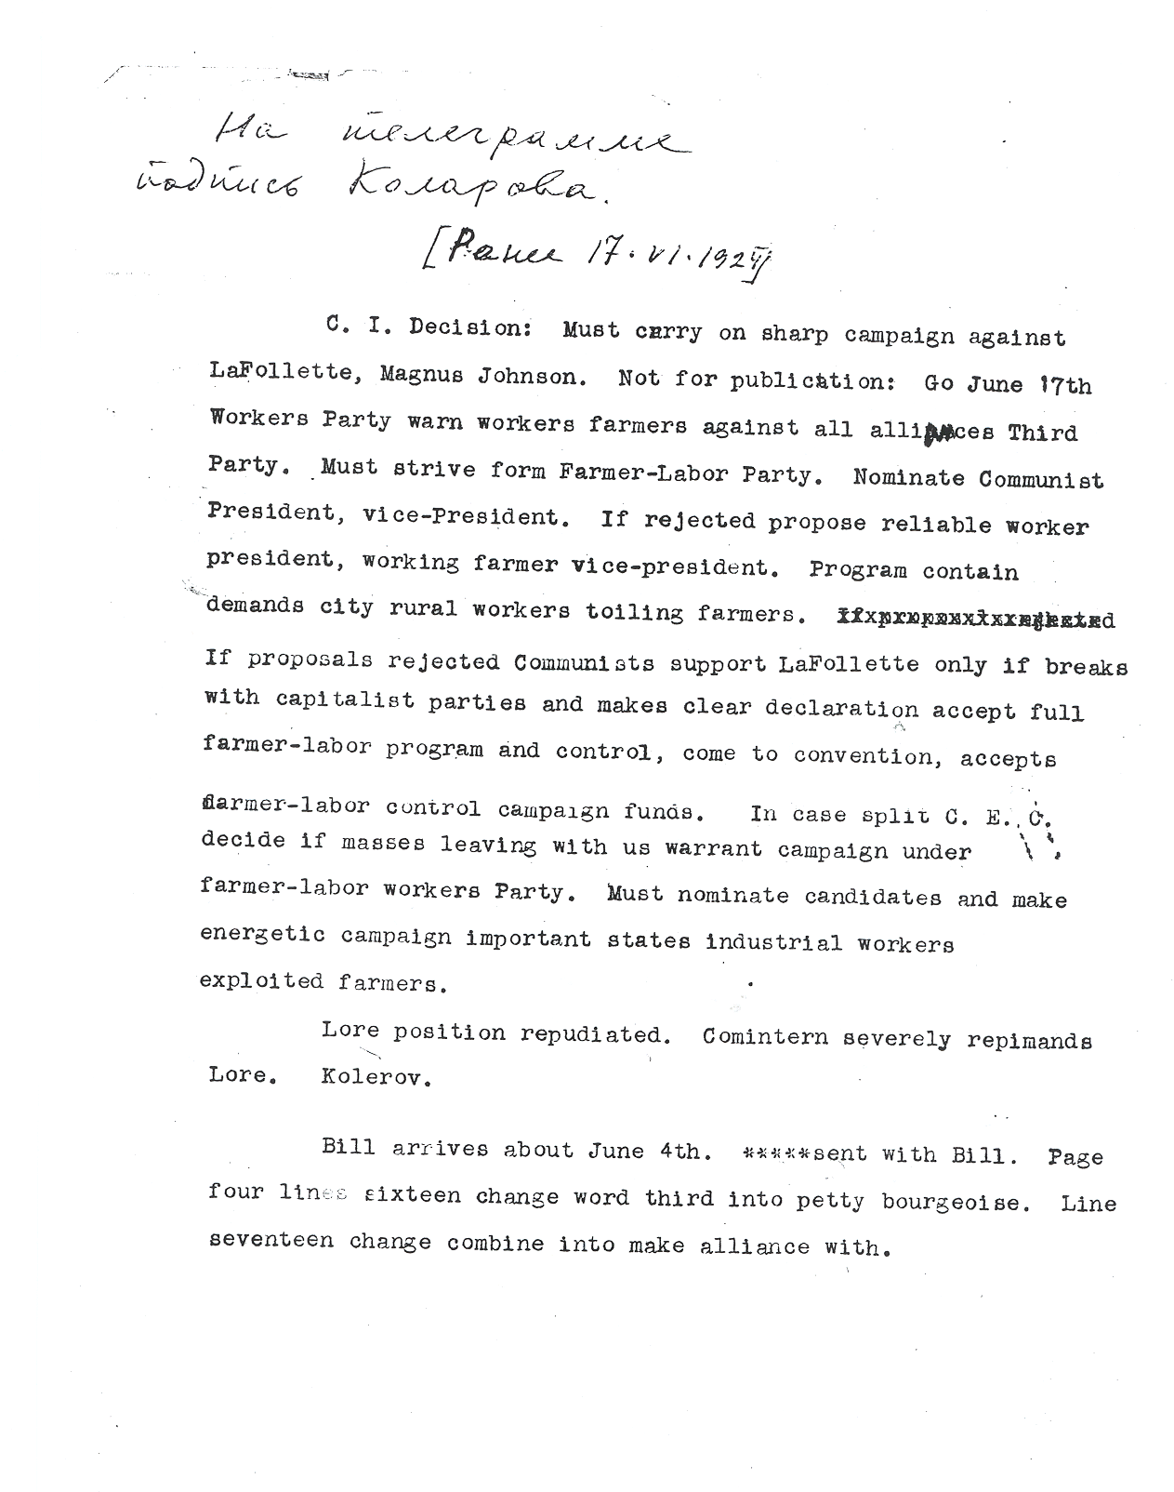
Document 6
Letter (transcription), 1938, CPUSA representative to Dimitrov of the Comintern acknowledging that in accordance with Comintern instructions the CPUSA will drop its slogan "Communism is Twentieth Century Americanism" but asking advice on how to publicly explain the decision. RGASPI Moscow 495-74-466
************************************************************************
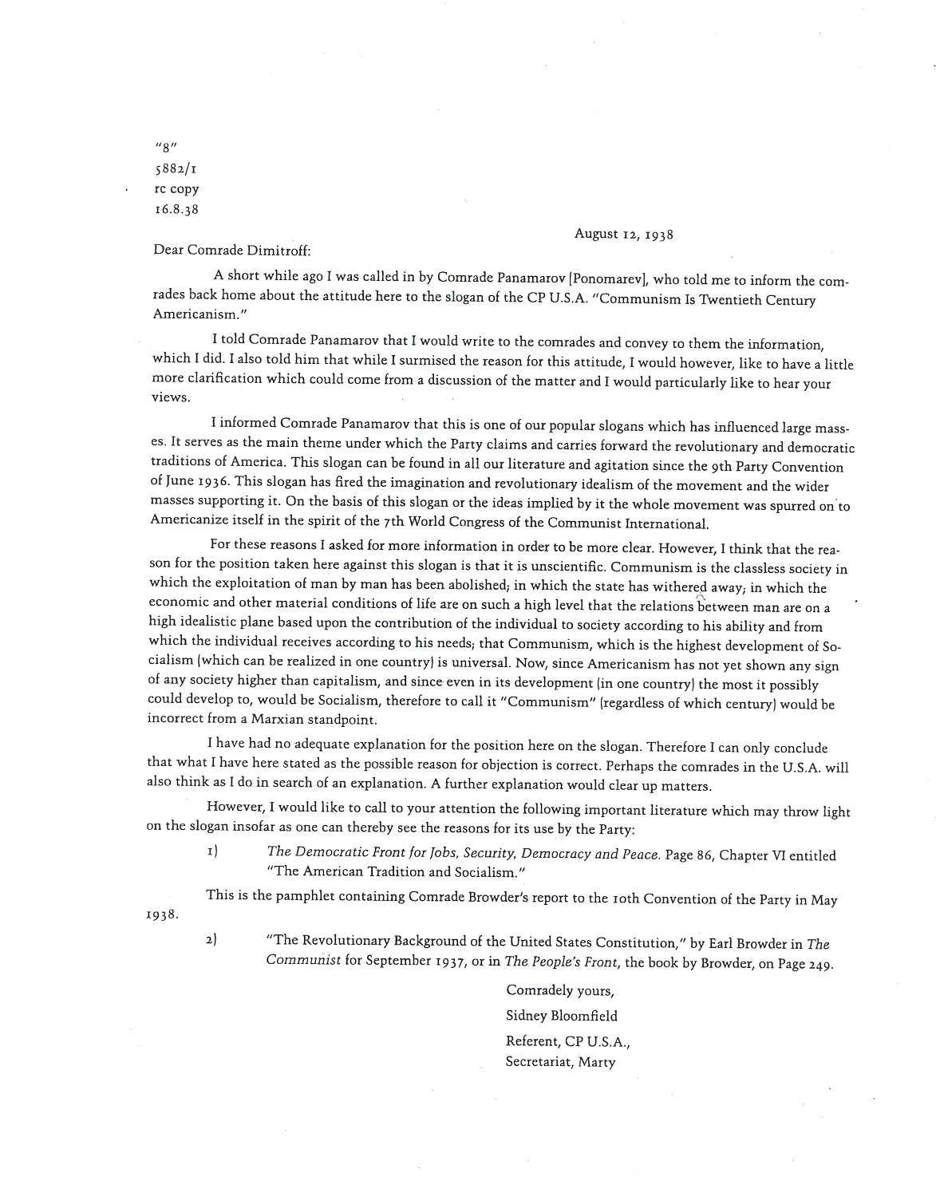
Document 7
Comintern cable, 1936, instructing the CPUSA to change its proposed slate of members of the Political Bureau, the party’s top executive officers. RGASPI Moscow 515-1-3961
*****************************************************************

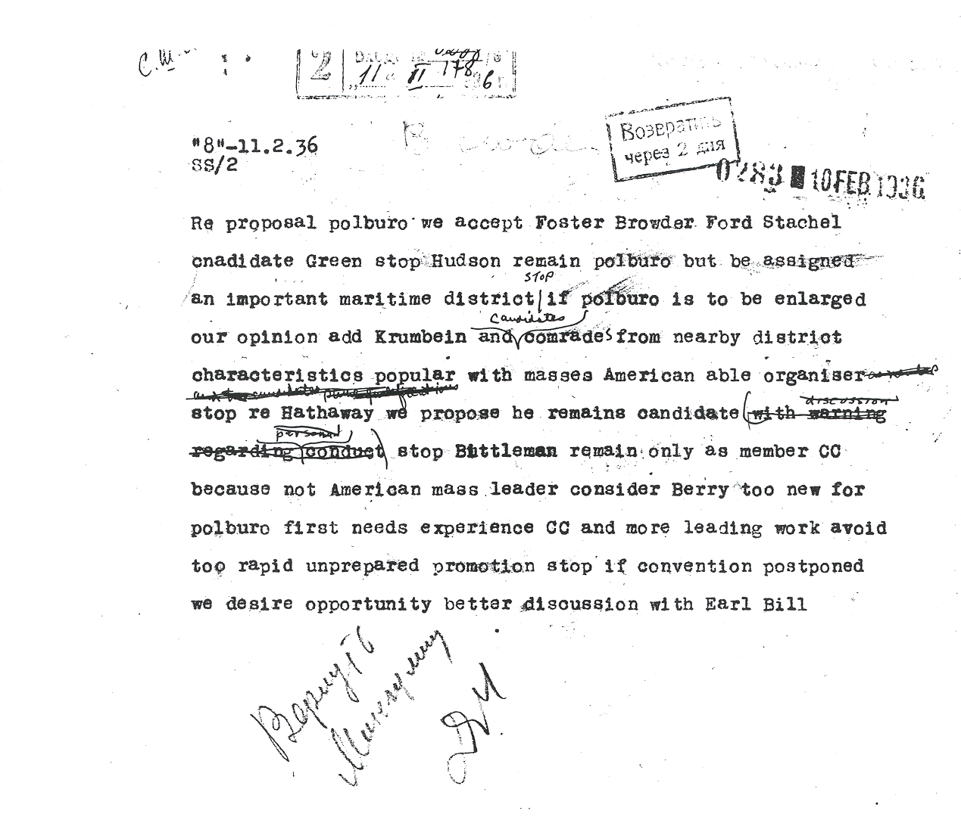
Document 8
Transcription/translation, cover, secret Bulletin of the Information Bureau of the Communist Party of the Soviet Union, listing a Soviet-written harsh criticism of the CPUSA that later appeared in the French Communist journal Les Cahiers du communisme with the by-line of Jacques Duclos RGASPI Moscow 17-128-754.
*****************************************************************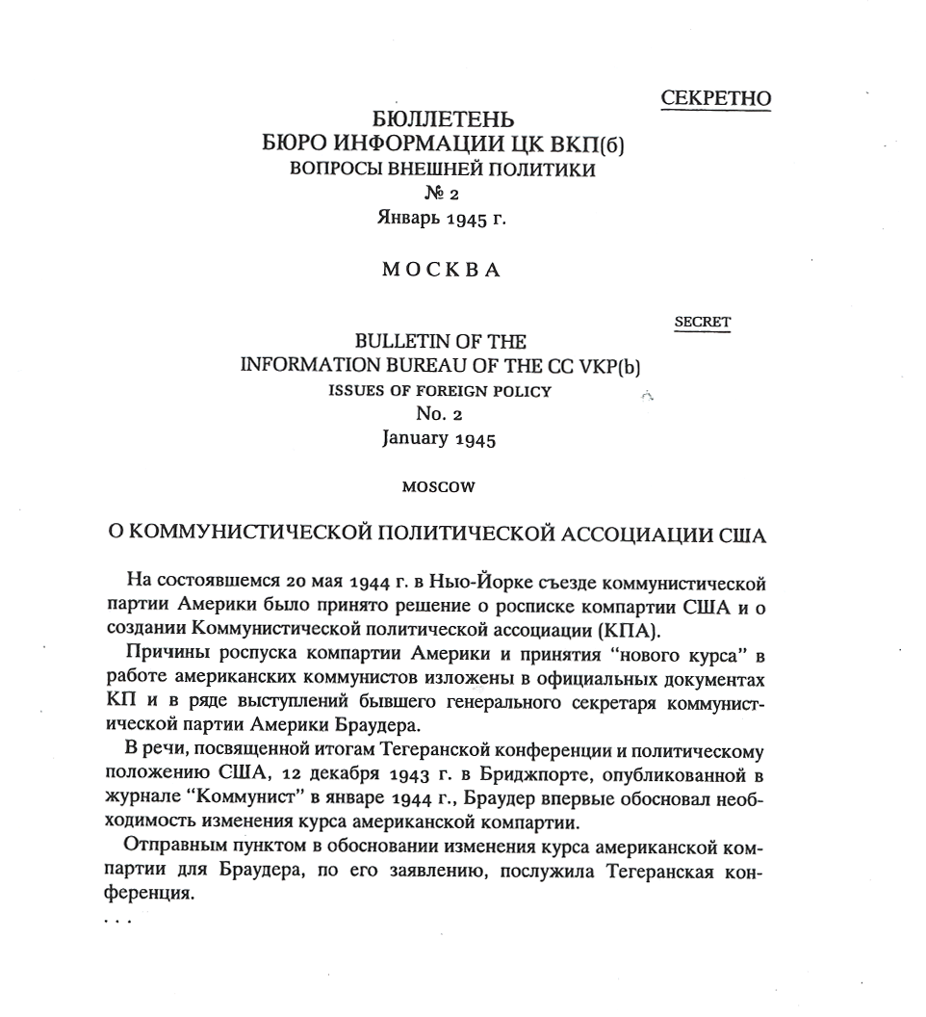
Document 9
Translation, part of a 1947 report, International Department of the Communist Party of the Soviet Union, regarding policy questions raised by Morris Childs (CPUSA representative) about which the CPUSA wanted Soviet guidance, chiefly on its political strategy in the 1948 American presidential election. RGASPI Moscow 17-128-1128
********************************************************************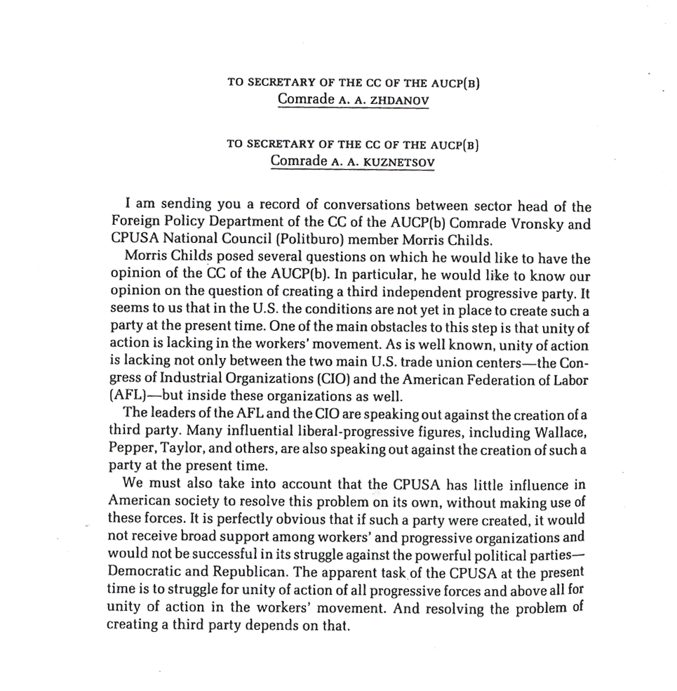
Document 10
Transcription, minutes of a Comintern Anglo-American Secretariat meeting, 1935, on the CPUSA ordering American party officers to criticize former CPUSA official Lovett Fort-Whiteman, then resident in Moscow. RGASPI Moscow 495-14-1
************************************************************************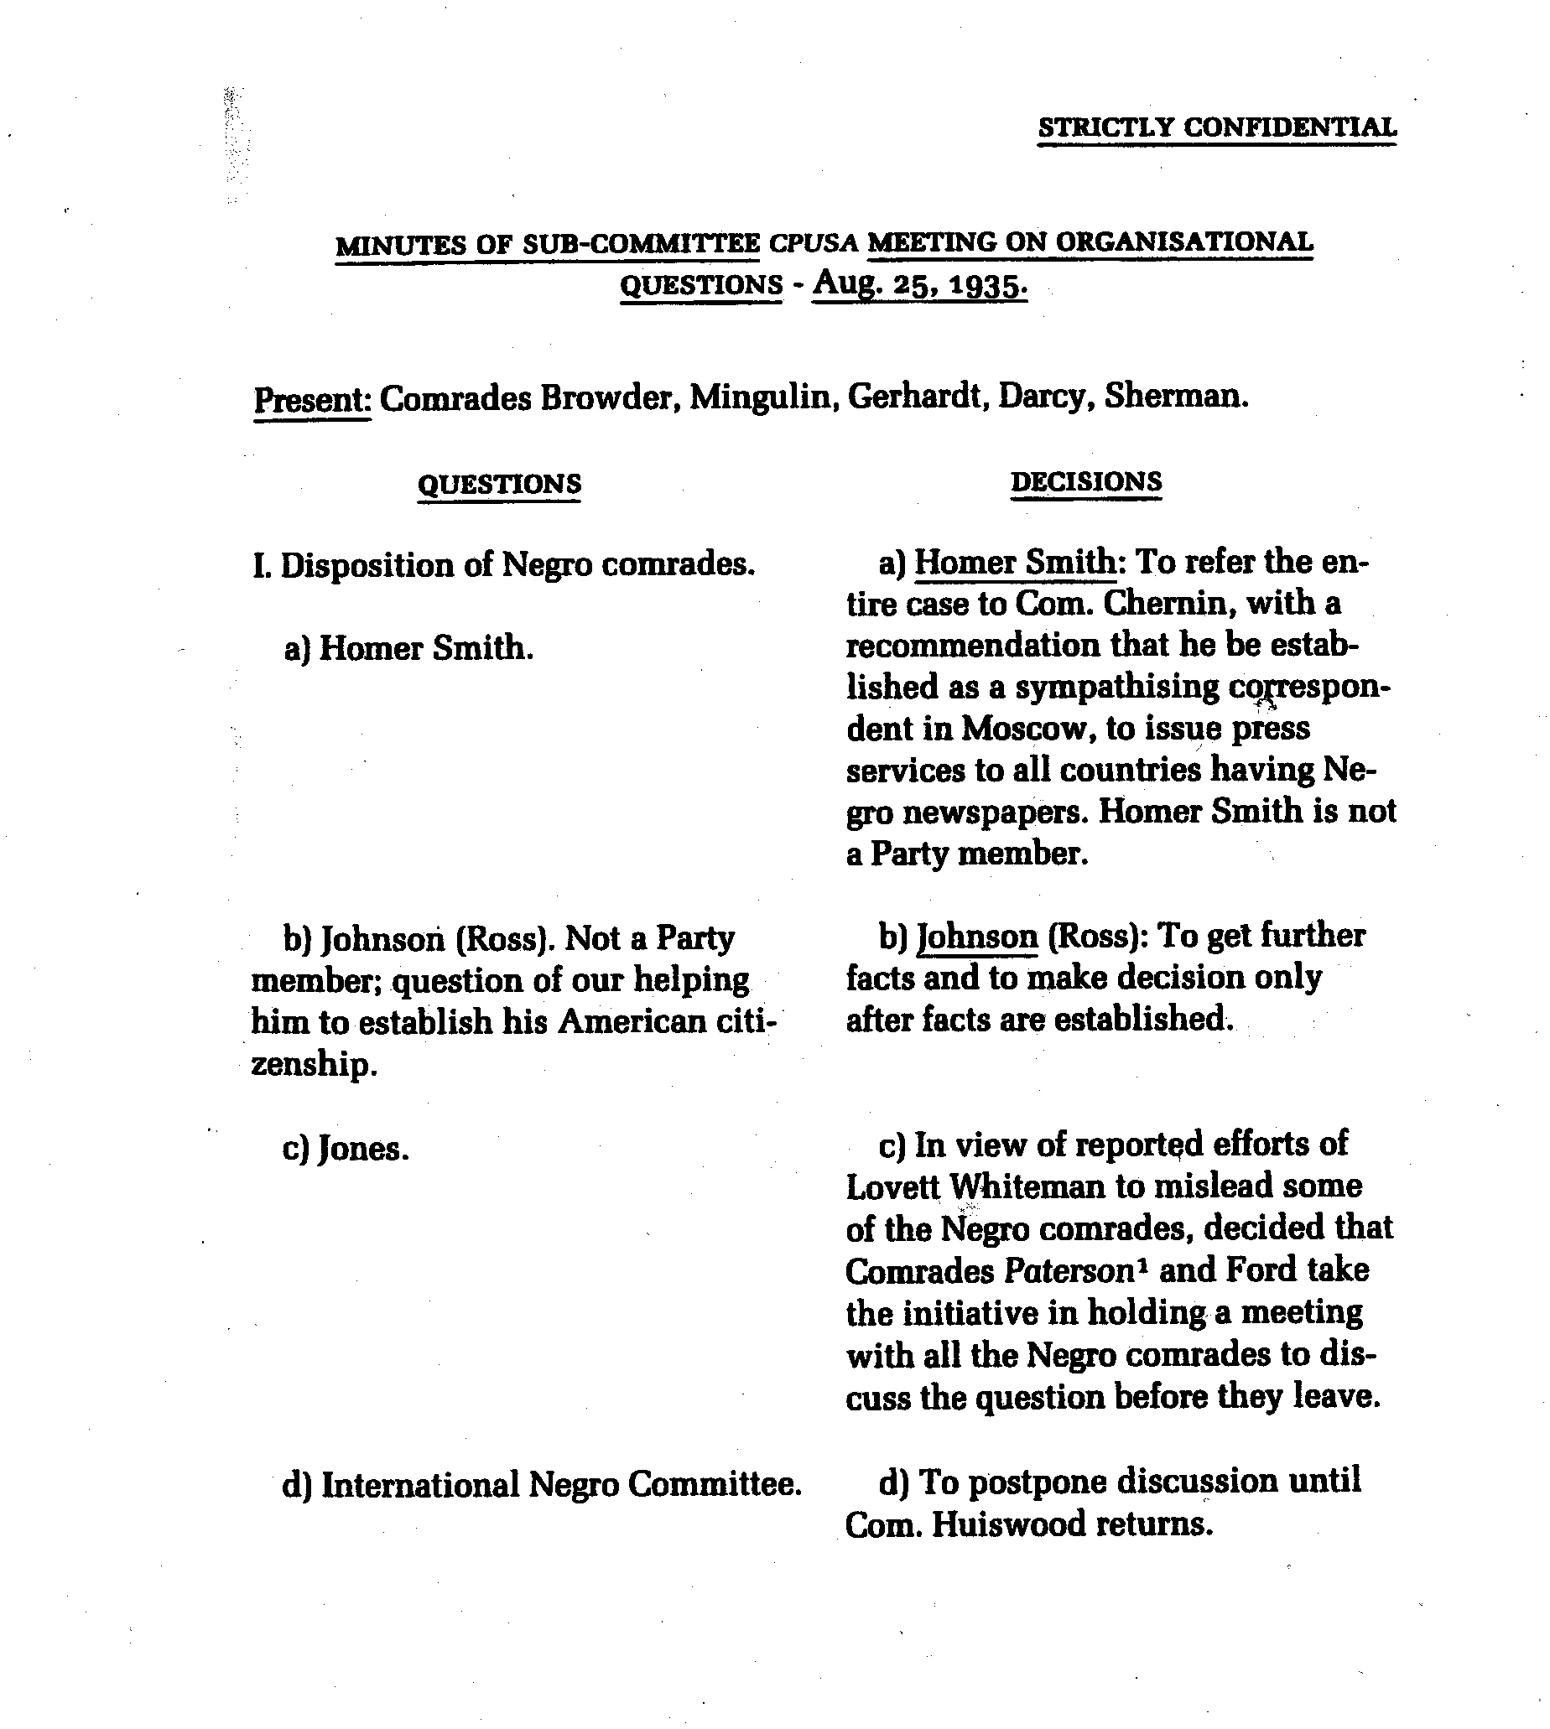
Document 11a
Death certificate, 1938, for Lovett Fort-Whiteman, American Communist, Sevostlag labor camp, Siberia, USSR, State Archive of the Russian Federation, Moscow
****************************************************************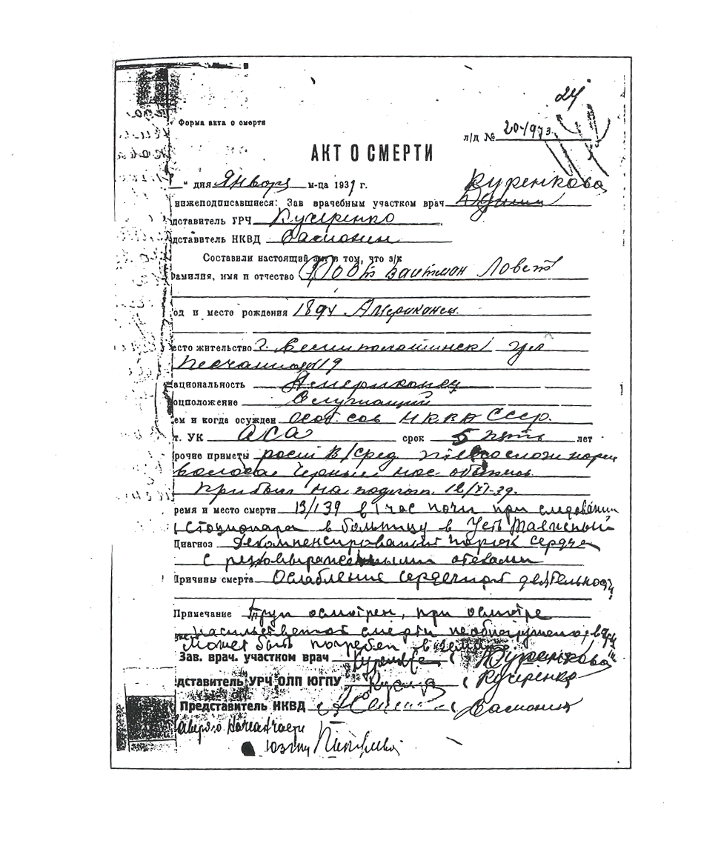
Document 11b
Translation: Lovett Fort-Whiteman GULAG death certificate. [Underlined material handwritten]
*****************************************************************************

Death certificate blank file sheet No. 204973
DEATH CERTIFICATE
13th day of January 1939
Undersigned: Physician in charge of medical sector Kurenkova
Representative of URCh [accounting and distribution unit] Kucherenko
Representative of NKVD Samonen
Have drafted the present document certifying that the prisoner
Surname, name and patronymic Fort-Whiteman, Lovett
Year and place of birth 1894 America
Permanent address 19 Peschannia St., Semipalatinsk
nationalist American
Social Position White-collar worker
By whom and when convicted Special board of the NKVD of the USSR
art. of criminal code Anti-Soviet agitation sentenced to 5 years
Other distinguishing features Above-average height, normal build, black hair, normal nose. Arrived for training 12/11/39 [may be garble fo 12/11/38]
Time and place of death 13/139 [possible garble for 13/12/39 or 13/1/40] at 1:00 at night en route [from] infirmary to the hospital at Ust-Taezhny
Diagnosis Decompensated heart defect with severe edema
Cause of death Weakening of cardiac activity
Remarks Corpse examined: examination did not indicate violent death. [Corpse] may be buried in [illegible]
Physician in charge of medical sector Kurenkova
Representative of the URCh OLP YuGPU [Accounting and distributive unit of the Detached Camp Section of the Southern Mining Industry Administration] Kucherenko
Representative of NKVD Samonen
[Illegible: the name of an additional administrative unit and the signature of its representative.]
Document 11c
Lovett Fort-Whiteman Death Certificate Fingerprints
*****************************************************************

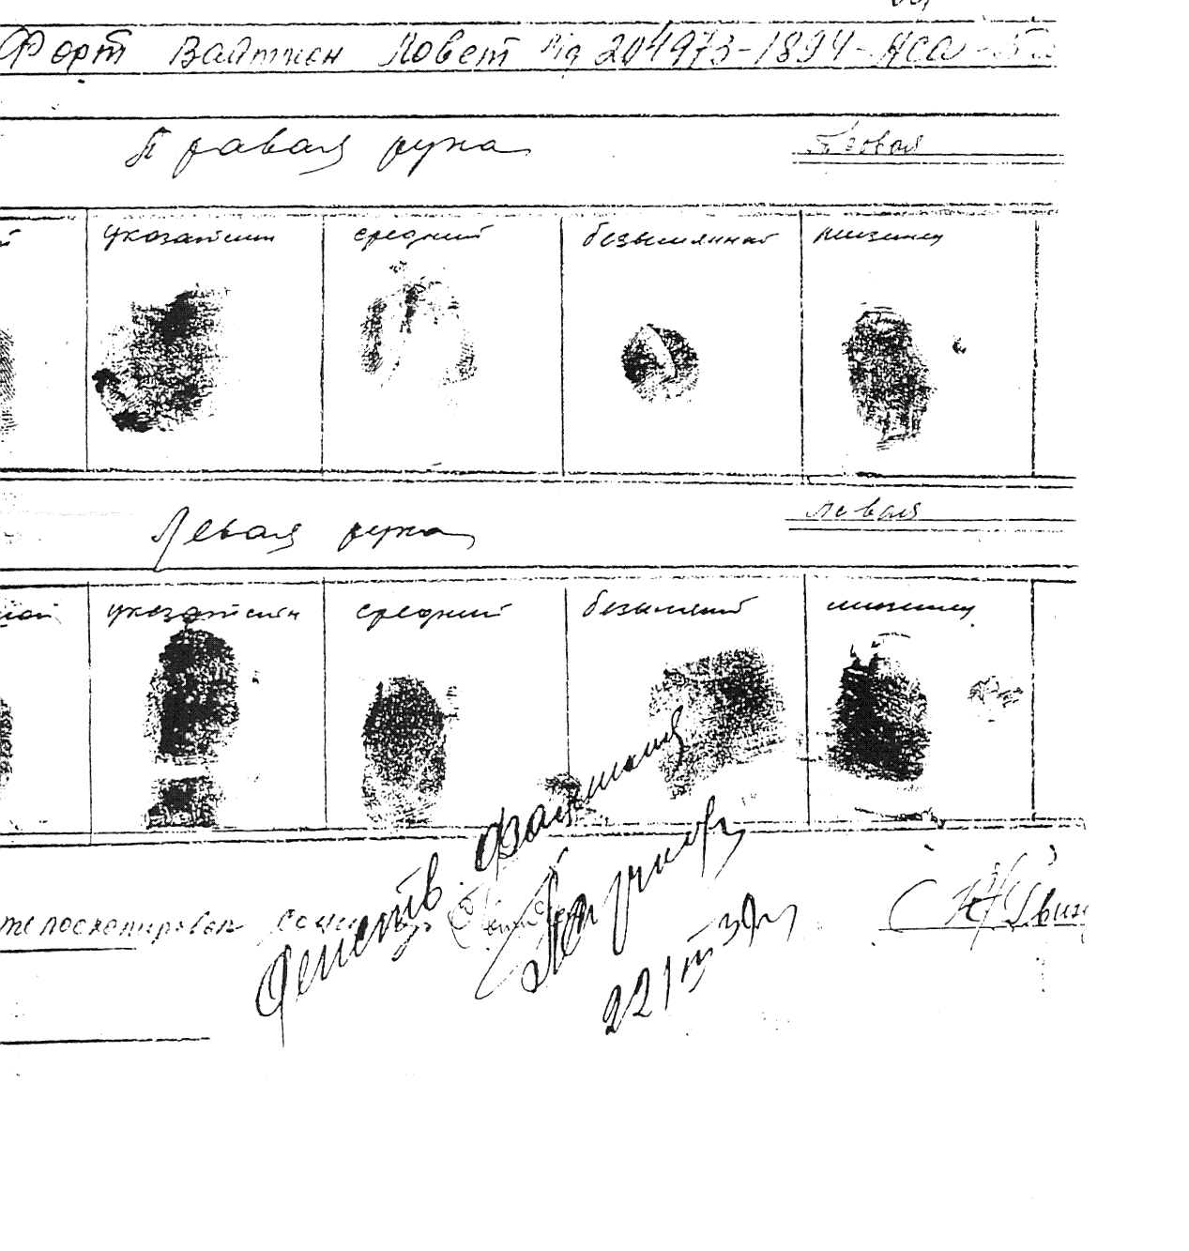
Document 12a
Thomas Sgovio NKVD (KGB) certificate of arrest, 22 March 1938, State Archive of the Russian Federation 10035-1-(p-26330, part 1).
************************************************************************
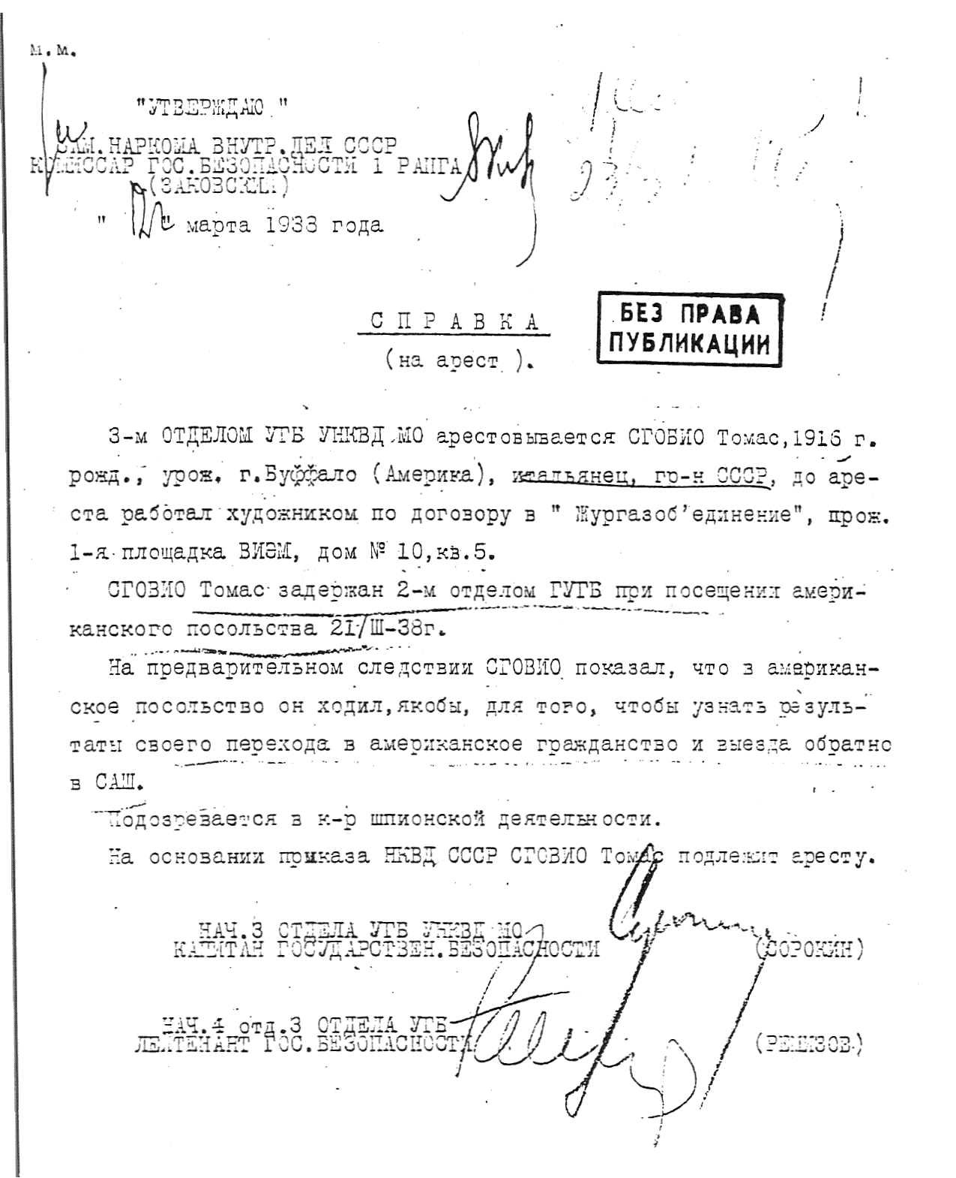
Document 12b
Translation: Thomas Sgovio NKVD (KGB) certificate of arrest. State Archive of the Russian Federation 10035-1-(p-26330, part 1). [Material in italic handwritten in original.]
*******************************************************************

M.M.

“I APPROVE”
ASST. PEOPLES COMMISSAR OF INTERNAL AFFAIRS USSR
COMMISSAR OF STATE SECURITY RANK #1
(ZAKOVSKY) ZAKOVSKY

“22” MARCH 1938

CERTIFICATE
(of arrest)

THE 3RD DEPT. UGB UNKVD. MO arrests SGOVIO TOMAS, born 1916; born in Buffalo (America); Italian; Citizen of USSR; Before arrest worked as an artist for “Jurgazobyedinyeni”; Lived at 1st Ploshada VIEM, #10, Apt. 5.

SGOVIO Tomas was detained by the 2nd Dept. GUGB after visiting the American Embassy on March 21, 1938.

During his first cross examination SGOVIO said he visited the American Embassy to inquire if there was news about his application to regain his American citizenship so as to return to the U.S.A.

There is suspicion here of counter-revolutionary espionage activities.

On the basis of orders from the NKVD USSR SGOVIO Tomas is under arrest.

CHIEF OF THE 3RD DEPT. UGB UNKVD MO
CAPTAIN OF STATE SECURITY SOROKIN (SOROKIN)

CHIEF OF THE 4TH BRANCH 3RD DEPT. UGB
LIEUTENANT OF STATE SECURITY REMIZOV (REMIZOV)
Document 12c
NKVD (KGB) prison mug shot for Thomas Sgovio, American Communist

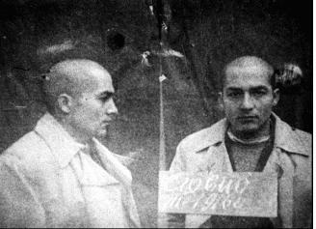
Document 12d
Thomas Sgovio GULAG Drawing: “Winter Work”
*********************************************************

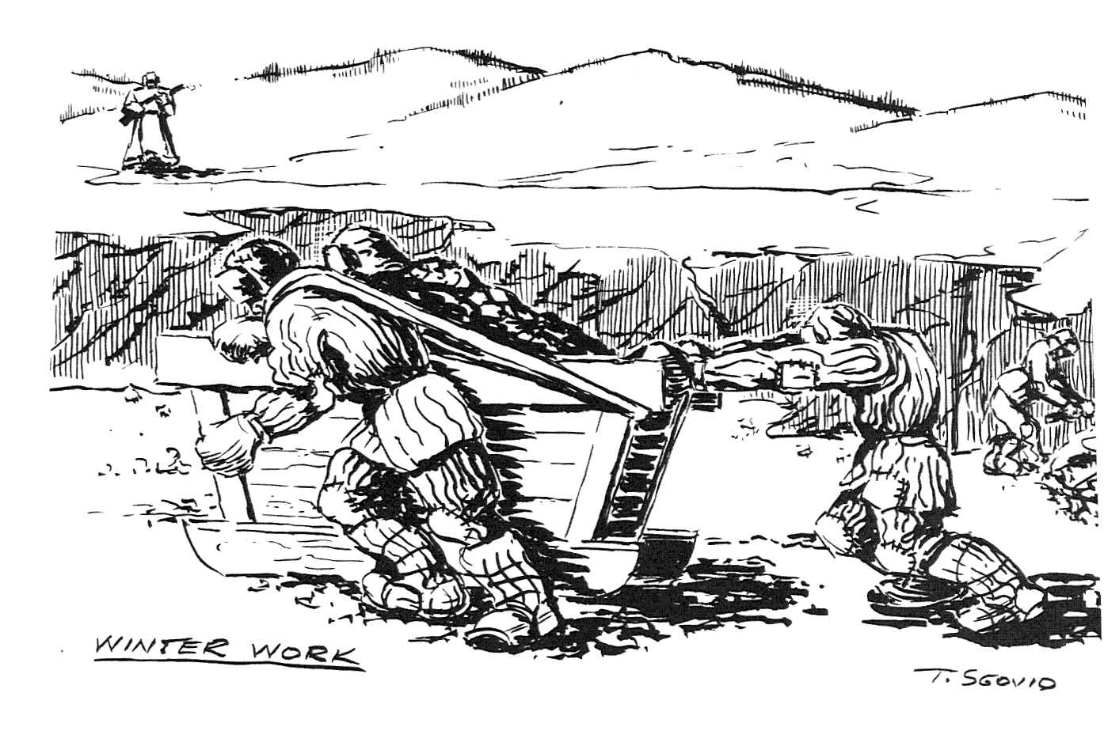
Document 12e
Thomas Sgovio GULAG Drawing
“Frost-Bite”
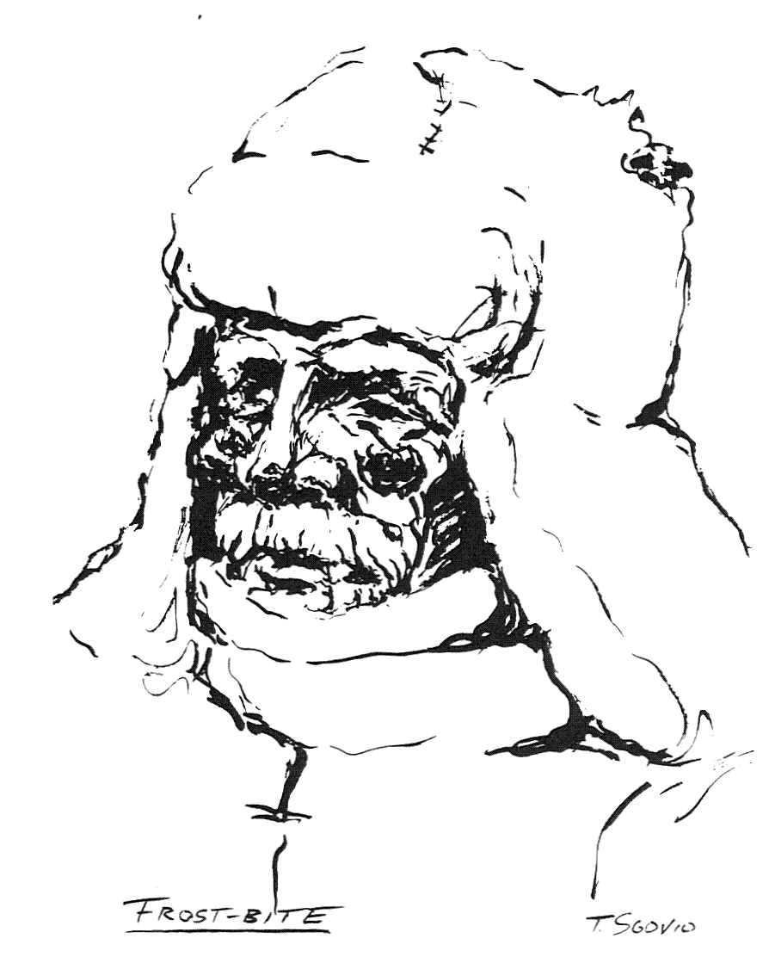
Document 12f
Thomas Sgovio GULAG Drawing: “Archive Nº Three”
************************************************************************
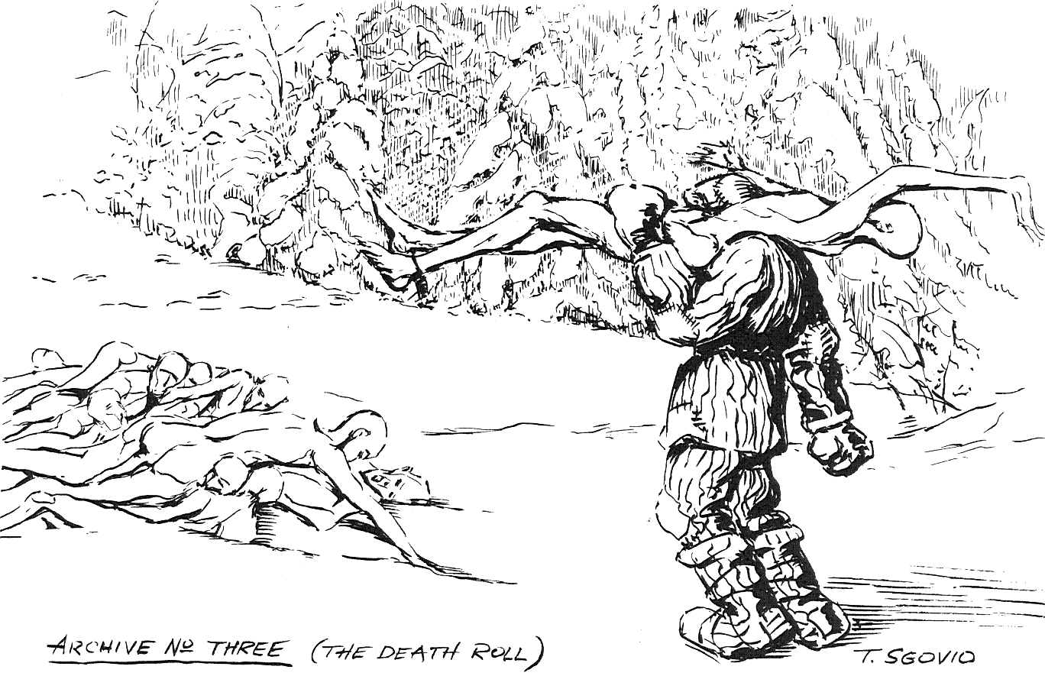
Document 13a
Photograph of memorial to the three murdered Finnish-American directors of the Soviet Karelian Technical Aid Committee at Sandarmokh KGB burial site.
*******************************************************************
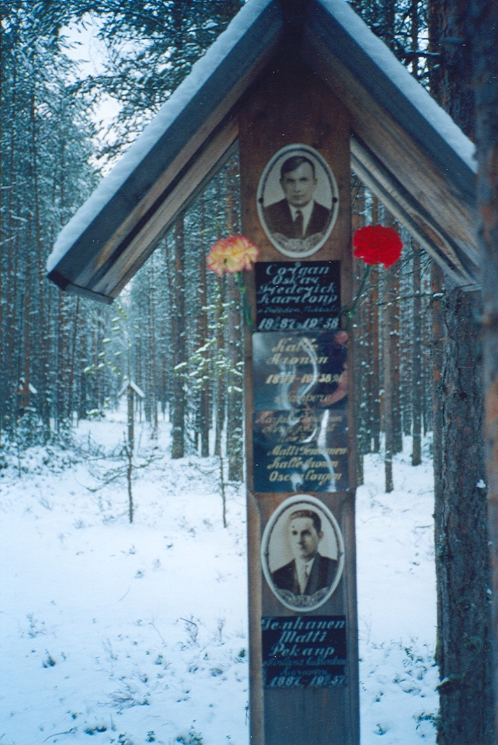

Document 13b
American Communists and Radicals Executed by Soviet Political Police
and Buried at Sandarmokh

A list of the names, biographical data, and dates of execution of 141 Finnish Americans buried in a secret KGB mass grave at Sandarmokh in the Karelian Republic, Russian Federation. Fourteen victims were American citizens by birth. It is unknown how many of the others, who immigrated to the United States early in the twentieth century, were naturalized citizens at the time of their move from the United States to the Soviet Union in the early 1930s.

Aaltio, Toimi Kallevich born 1913, Red Granite, Wisconsin; emigrated from USA in 1931; driver, Vilga machine station; executed 11 February 1938.

Bjorklund, Adolf Leanderovich born 1878, Finland; emigrated from Wisconsin in 1932; logger; executed 22 April 1938.

Bjorn, Eino Antonovich born 1912, Angora, Minnesota; emigrated from USA in 1932; driver, mechanic, Vilga machine station; executed 10 February 1938.

Corgan, Oskar Fredrik Karlovitsh born 1887, Sweden; emigrated from USA in 1934; book shop director; executed 9 January 1938.

Ekholm, Arvid Oskarovich born 1908, Finland; emigrated from Baltimore, Maryland, in 1931; driver; executed 21 January 1938.

Elo, Johan Gustavovich born 1889, Finland; emigrated from Quincy, Massachusetts, in 1931; blacksmith; executed 21 January 1938.

Erkkilä, Eino Fridrihovich born 1908, Finland; emigrated from Detroit, Michigan, in 1932; blacksmith; executed 3 April 1938.

Ernest, Kalle Oskarovich born 1895, Finland; emigrated from Sebeka, Minnesota, in 1931; logger; executed 22 April 1938.

Eskola, Samuel Ivanovich (Juho) born 1882, Finland; emigrated from Massachusetts in 1931; driver; executed 28 December 1937.

Eskolin, August Einar Augustovich born 1894, Finland; emigrated from Brooklyn, New York, in 1931; motor operator; executed 28 April 1938.

Filpus, Elvira Karlovna born 1888, Finland; emigrated from Detroit, Michigan, in 1933; housewife; executed 21 January 1938.

Filpus, Niilo Ollivich born 1880, Finland; emigrated from Detroit, Michigan, in 1933; metal worker at Lososina car depot; executed 21 January 1938.

Finberg, Väinö Karlovich born 1892, Finland; emigrated from Superior, Wisconsin, in 1931; journalist; executed 10 February 1938.

Fors, Antti Matvejevich (Matti) born 1878, Finland; emigrated from USA in the late 1920s; carpenter; executed 10 February 1938.

Goldberg, Juho Ivanovich (Juho) born 1891, Finland; emigrated from Astoria, Oregon, in 1931; carpenter; executed 8 May 1938.

Grandel (Ruohisto), Toivo Viktorovich born 1898, Finland; emigrated from Detroit, Michigan, in 1933; metal worker; executed 9 January 1938.

Hakkarainen, August Olavich (Olavi) born 1901, Finland; emigrated from USA in 1932; carpenter; executed 28 December 1937.

Halonen, Vaino Fridanovich (Fritjof) Oskarovich born 1891, Finland; emigrated from USA in 1924; metal worker, timber floating site in Karelia; executed 9 January 1938.

Halme, Iivari Iisakovich born 1885, Finland; emigrated from Newberry, Michigan, in 1932; logger; executed 20 January 1938.

Hannula, Andrew Osvaldovich born 1913, Washington State; emigrated from USA in 1932; electrician, Petrozavodsk power plant; executed 28 December 1937.

Hannula, Nikolai Matvejevich (Matti) born 1902, Finland; emigrated from Angora, Minnesota, in 1931; mechanic at sawmill; executed 10 February 1938.

Heikanen, Jaakko Matveevich (Matti) born 1895, Finland; emigrated from USA in 1932; tractor driver; executed 20 January 1938.

Heikkila, Artur Matveevich (Matti) born 1892, Finland; emigrated from USA in 1932; metal worker, Kolodozero logging center; executed 8 May 1938.

Heikkinen, Vaino Erikovich born 1908, Finland; emigrated from Phelps, Wisconsin, in 1931; logger; executed 21 January 1938.
Heino, Frank (Frans Luther) Ivanovich (Juho) born 1887, Finland; emigrated from Menagha, Minnesota; paper mill worker; executed 22 April 1938.

Helander, Yrjo Niilo Andreevich (Antti) born 1899, Finland; emigrated from USA in 1932; naturalized American citizen; construction mechanic; executed 20 January 1938.

Helin, Evert Stepanovich (Teppo) born 1888, Finland; emigrated from Chicago, Illinois, in 1932; carpenter; executed 28 December 1938.

Heimonen, Edvard Juho Abelevich born 1887, Finland; emigrated from USA in 1931; dock laborer; executed 20 January 1938.

Hendriksson, Stepan Stepanovich (Aleksanteri Akseli) born 1893, Finland; emigrated from Brooklyn, New York, in 1932; foreman at printing house; executed 10 February 1938.

Hendriksson, Juho Matveevich (Matti) born 1886, Finland; emigrated from USA in 1932; metal worker; executed 10 February 1938.

Henell, Benjamin Jakovlevich (Jaakko) born 1905, Finland; emigrated from USA in 1932; culture worker, Kiestinki house of culture; executed 9 January 1938.

Herrala, Erkki Antonovich born 1896, Finland; emigrated from Spencer, New York, in 1932; carpenter, Solomennoye power plant; executed 3 April 1938.

Hill, (Maki) Helen Oskarovna born 1917, Minnesota; emigrated from USA in 1932; logging dispatcher; executed 22 April 1938.

Hill (Mäki), Oskar Henrikovich born 1888, Finland; emigrated from Minnesota in 1931; logger; executed 15 May 1938.

Hill, Otto Matveevich (Matti) born 1890, Finland; emigrated from USA in 1933; logger; executed 21 April 1938.

Hiltunen, Jaakko Ivanovich (Juho) born 1881, Finland; emigrated from USA in 1922 to Knosas fishing commune; executed 21 January 1938.

Honkanen, William Johannesvich born 1903, St. Petersburg, Russia; emigrated from USA in 1932; logger and secretary of local Soviet Communist Party unit; executed 9 January 1938.

Huuki, Karl (Kalle) Karlovich born 1898, Finland; emigrated from Ohio in 1931; carpenter; executed 28 December 1938.

Huttunen, David Simovich born 1884, Finland; emigrated from USA in 1922; worker, Suontale brick factory; executed 21 April 1938.

Isaakson, Tuomas Tuomasovich born 1894, Rock Springs, Wyoming; emigrated from Canada in 1931; mechanic; executed 3 April 1938.

Jääskeläinen, Juho Davidovich born 1884, Finland; emigrated from Gardner, Massachusetts, in 1934; logger; executed 8 May 1938.

Jarvenpaa, Eero Matvejevich (Matti) born 1905, Finland; emigrated from USA in 1931; sawmill worker; executed 20 January 1938.

Jokela, Johan Erikovitsh born 1883, Finland; emigrated from USA in 1931; school carpenter; executed 20 January 1938.

Jormalainen, Alpo Heikkivich born 1910, Finland; emigrated from USA in 1932; post office driver; executed 20 January 1938.

Kaartinen, Eino Anttivich born 1912, Finland; emigrated from USA in 1932; logger; executed 21 April 1938.

Kaartinen, Mathew Alfredovich born 1907, Ironwood, Michigan; emigrated from USA in 1931; mechanic; executed 28 December 1937.

Kaipainen, Johan Ivanovitsh (Juho) born 1887, Finland; emigrated from USA in 1932; deputy director of construction agency; executed 21 January 1938.

Kajander, Niilo Davidovich born 1901, Finland; emigrated from USA in 1932; logger; executed 22 April 1938.

Kallio, Arvid Valentinovich born 1888, Finland; emigrated from USA in 1932; logger; executed 11 February 1938.

Kallio, Julius Andreevich (Antti) born 1891, Finland; emigrated from USA in 1931; actor, Petrozavodsk national theater; executed 10 February 1938.

Kangas, Matti Erikovich born 1904, Finland; emigrated from USA in 1931; logger; executed 3 April 1938.

Karlson, Karl Augustovich born 1894, Finland; emigrated from USA in 1932; turner for Sunastroi; executed 8 May 1938.

Karlstedt, Viktor Maurivich born 1892, Finland; emigrated from USA in 1931; driver; executed 10 February 1938.

Kemppainen, Valdemar Ivanovich (Juho) born 1883, Finland; emigrated from USA in 1931; driver; executed 20 January 1938.

Ketola, Eino Vilhovich born 1891, Finland; emigrated from USA in 1932; carpenter in cooperative for the disabled; executed 10 February 1938.

Kivistö, Karl Ivanovich (Juho) born 1896, Finland; emigrated from USA in 1931; carpenter; executed 6 March 1938.

Koivu, Onni Aleksandrovich born 1914, USA; emigrated from USA in 1931; tractor driver; executed January 20, 1938.

Koivulehto (Kinnunen), Otto Nikolaevich born 1894, Finland; emigrated from Aurora, Minnesota, in 1932; sawfitter, Santala tractor station; executed 21 January 1938.

Koivuluoma, Jaakko Ionovitsh (Johan, Joonas?) born 1897, Finland; emigrated from Maine in 1931; logger; executed 22 April 1938.

Korpi, Arvo Ivanovich (Juho) born 1892, Finland; emigrated from USA in 1931; driver; executed 20 January 1938.

Korpi, Jaakko Ionosovich (Joonas) born 1898, Finland; emigrated from USA in 1932; logger; executed 3 April 1938.

Korpi, Oskar Aleksandrovich born 1891, Finland; emigrated from Quincy, Massachusetts, in 1932; mechanic; executed 20 January 1938.

Kortes (Lähdeskorpi), Viktor Maurivich born 1892, Finland; emigrated from Michigan in 1931; driver, construction company; executed 10 February 1938.

Koskelainen, Aleksandr Ivanovich (Juho) born 1899, Finland; emigrated from Aberdeen, Washington, in 1928; foreman and mechanic; executed 11 February 1938.

Koski, Kalle Villevich born 1888, Finland; emigrated from USA in 1934; logger; executed 10 February 1938.

Kuusela, (Kakkonen)Antti Jakovlevich (Jaakko) born 1893, Finland; emigrated from USA in 1932; logger, Padozero-Vidany tractor station; executed 6 March 1938.

Laakso, Toivo Osipovich (Jooseppi) born 1892, Finland; emigrated from USA in 1932; factory worker; executed 21 April 1938.

Laakso, Uuno (Niva Einari) Ionovich (Joonas) born 1900, Finland; emigrated from Frederick, South Dakota, in 1931; member of the Soviet Communist Party (VKP/b) and taught Communist Party history at party school, Petrozavodsk; executed 11 February 1938.

Laine, Vilho Enoch Vilgemovitsh born 1901, Finland; emigrated from Pennsylvania in 1933; instructor at lumbering site; executed 20 January 1938.

Laitinen, Martti Alfredovich born 1902, Finland; emigrated from USA in 1931; painter at hospital; executed 9 January 1938.

Laukkanen, Antti Albinovich born 1891, Finland; emigrated from Rock, Michigan, in 1932; carpenter; executed 5 March 1938.

Lehto, Väinö born 1904, Finland; emigrated from Detroit, Michigan, in 1932; electrician at Solomennoye hydropower station; executed 3 April 1938.

Lehtola, Vaino Andreevich (Antti) born 1912, Finland; emigrated from USA in 1932; logger; executed 28 April 1938.

Leinonen, Vilho Matveevich (Matti) born 1891, Finland; emigrated from USA in 1932; sawmill worker; executed 11 January 1938.

Leivo, Hugo Germanovich (Herman) born 1888, Finland; emigrated from USA in 1931; road builder; executed 3 April 1938.

Levanen, Abel Aleksandrovich born 1883, Finland; emigrated from Hancock, Michigan, in 1931; metal worker, Kondopoga paper mill; executed 28 April 1938.

Lindkvist, Otto Gustavovich born 1887, Finland; emigrated from Massachusetts in 1931; worker, Uhtua machine and tractor station; executed 5 March 1938.

Lumio, Toivo Davidovich born 1886, Finland; emigrated from USA in 1932; painter for Karelstroi; executed 3 April 1938.

Luoma, Lauri Ludvig Mihailovich (Mikko) born 1895, Finland; emigrated from USA in 1931; foreman for Karelstroi; executed 6 March 1938.

Maki, Juho Matveevich (Matti) born 1879, Finland; emigrated from Pennsylvania in 1932; mechanic, Vilga machine station; executed 11 February 1938.

Maki, Walter Walterovich born 1907, Minnesota; emigrated from USA in 1931; carpenter; executed 15 May 1938.

Maki, George (Yrjo) Karpovich born 1888, Finland; emigrated from USA in 1934; logger; executed 22 April 1938.

Makkonen, Karl Ivanovich (Juho) born 1899, Finland; emigrated from USA in 1932; logger; executed 6 March 1938.

Mantyla, Toivo Mihailovich (Mikko) born 1911, Finland; emigrated from Gardner, Massachusetts, in 1932; tractor driver, electrician; executed 8 May 1938.

Matson, Eino Walfredovich born 1909, Finland; emigrated from Queen Village, Illinois, in 1931; plumber; executed 11 February 1938.

Matson, Henry (Heikki) Henrikovich born 1891, Finland; emigrated from Massachusetts in 1932; metal worker, Central Repair Works; executed 8 May 1938.

Merilä, Leo (Leonard) Stepanovich (Teppo) born 1886, Finland; emigrated from Grand Rapids, Michigan, in 1931; carpenter; executed 20 January 1938.

Moisio, Jaakko Ioganovich (Johannes) born 1877, Finland; emigrated from USA in 1931; carpenter; executed 6 March 1938.

Multimäki, Ivan Ivanovich (Johan Juhovich) born 1880, Finland; emigrated from Rhode Island in 1932; logger; executed 22 April 1938.

Myllari, Otto Karlovich born 1898, Finland; emigrated from Ohio in 1932; sawfitter; executed 6 March 1938.

Nahkala Juho Fedorovich (Heikki) born 1884, Finland; emigrated from USA in 1931; metal worker at a paper mill; executed 22 April 1938.

Nelson (Poukkula), Enoch Jakovlevich (Jaakko) born 1897, San Francisco, California; emigrated from USA in 1921; member of the Soviet Communist Party (VKP/b); director of industrial enterprise, Uhtua; executed 5 March 1938.

Niemi, Andrei Ioganovitsh (Antti Johannesovich) born 1886, Finland; emigrated from New York in 1931; carpenter, city hall, Petrozavodsk; executed 6 March 1938.

Nikander, Svante Gustavovich, Korila (Karila?) born 1882, Finland; emigrated from USA in 1931; logger, Vilga machine station; executed 10 February 1938.

Niva, Emil Nikodimusovich (Nikodemus) born 1882, Finland; emigrated from USA in 1931; carpenter; executed 11 February 1938.

Oinonen, Eino Ottovich born 1906, Finland; emigrated from USA in 1932; tinsmith; executed 10 February 1938.

Oja, Aleksi Viktorovich born 1892, Finland; emigrated from Minnesota in 1931; metal worker; executed 3 April 1938.

Oksanen-Porvali, Anna Mihailovna (Mikko) born 1897, Finland; emigrated from Gardner, Massachusetts, in 1932; housewife, Petrozavodsk; executed 21 April 1938.

Olkinuora, Armas Andreevich (Antti) born 1902, Finland; emigrated from USA in 1931; mechanic; executed 11 February 1938.

Paakkonen, Matti Petrovich (Pekka) born 1898, Finland; emigrated from USA in 1930; handicraft worker, Kustprommetal cooperative; executed 11 February 1938.

Paju, Emil Matveevich (Matti) born 1878, Finland; emigrated from Cleveland, Ohio, in 1931; stove/fireplace mason; executed 10 February 1938.

Paju, Viktor Emilevich born 1908, Finland; emigrated from USA in 1931; worker at ink-making shop; executed 20 January 1938.

Peltonen, Kaarlo Kaarlovich born 1886, Finland; emigrated from Astoria, Oregon, in 1930; blacksmith; executed 28 April 1938.

Pesonen, Feliks Emelianovitsh (Emil) born 1895, Finland; emigrated from New York in 1931; club manager, Lososina lumbering site; executed 10 February 1938.

Pietilä, Alfred Ivanovich born 1911, Washington State; emigrated from Aberdeen, Washington, in 1923 to “Sower” commune; then driver, Petrozavodsk; executed 6 March 1938.

Pyykkö, Mihail Matveevich (Mikko Mattivich) born 1884, Finland; emigrated from USA in 1931; carpenter; executed 10 February 1938.

Rantala, Toivo Isakovich born 1904, Finland; emigrated from Oregon in 1932; worker at Onega tractor factory; executed 3 April 1938.

Rantaniemi, Toivo Ivanovich (Juho) born 1906, Finland; emigrated from USA in 1934; carpenter; executed 3 April 1938.

Rautio, Antti Uunovich born 1909, Finland; emigrated from USA in 1931; driver, Vilga machine station; executed 11 February 1938.

Ruuskanen, Uuno Pavlovich (Paavo) born 1908, Finland; emigrated from Minnesota in 1931; driver; executed 9 January 1938.

Saarenpaa, Solomon Mihailovich (Mikko) born 1881, Finland; emigrated from Marshfield, Oregon, in 1932; mechanic; executed 9 January 1938.

Saastamoinen, Robert Robertovich born 1888, Finland; emigrated from Ishpeming, Michigan, in 1933; logger; executed 10 January 1938.

Salmi, Kalle Rihardovich born 1897, Finland; emigrated from Chicago, Illinois, in 1931; logger; executed 21 January 1938.

Salminen, Eino Gustavovich (Kustaa) born 1906, Finland; emigrated from USA in 1931; actor, Uhtua National Theater; executed 22 April 1938.

Salminen, Eino Karlovitsh born 1901, Finland; emigrated from Chicago, Illinois, in 1931; mechanic; executed 20 January 1938.

Salminen, Richard Nikolaevich born 1883, Finland; emigrated from New York in 1930; school janitor; executed 11 February 1938.

Salo, Simo Jegorovich (Yrjo) born 1890 Finland; emigrated from USA in 1931; foreman for Karelstroi; executed 6 March 1938.

Salo, Yrjo Petrovich (Pekka) born 1898, Finland; emigrated from Ishpeming, Michigan, in 1932; carpenter, Vilga machine station; executed 11 February 1938.

Salonen, Toivo Gustavovich (Kustaa) born 1904, Finland; emigrated from USA in 1931; set painter at Uhtua National Theater; executed 21 January 1938.

Saviniemi, Elis Fedorovich (Heikki) born 1898, Finland; emigrated from USA in 1931; logger; executed 8 May 1938.

Silvan, Rafael Vainovich born 1916, New York; emigrated from USA in 1933; mechanic, car repair shop; executed 5 March 1938.

Siren (Kari), John Ioganovich (Johan) born 1915, Duluth, Minnesota; emigrated from USA in 1932; paper mill electrician; executed 11 February 1938.

Solkela, Severi (Seth) Yakovlevich (Jaakko) born 1902, Chassel, Michigan; emigrated from USA in 1930; accordian player, Kiestenga club; executed 9 January 1938.

Tabell, Isaak Eino Isaakovich born 1904, Finland; emigrated from USA in 1932; borer, Samoilovich mine; executed 21 January 1938.

Tamminen, Toivo Fritovich (Frithof) born 1887, Finland; emigrated from USA (or Canada, records unclear) in 1931; construction worker; executed 6 March 1938.

Tenhunen, Matti Petrovich (Pekka) born 1883, Finland; emigrated from USA in 1931; head of the Karelian Council of People’s Comissariats Labor Department; publishing house director; executed 28 December 1937.

Terhonen, Johan Martynovich (Martin) born 1903, Finland; emigrated from USA in 1932; auto mechanic, Lososina transport center; executed 11 February 1938.

Tolonen, Eino Venjaminovich (Benjamin) born 1888, Finland; emigrated from Detroit, Michigan, in 1931; mason; executed 28 April 1938.

Tuomainen, Aksel Juhovich born 1895, Finland; emigrated from USA in 1932; carpenter; executed 28 December 1937.

Tuominen, Yrjo (Georg) Viktorovitsh born 1896, Finland; emigrated from USA in 1932; director, railroad tie factory; executed 28 December 1937.

Tuominen, Väinö Fedorovich (Heikki) born 1904, Finland; emigrated from USA in 1931; driver; executed 10 February 1938.

Turunen, Toivo Ottovich born 1912, Finland; emigrated from USA in 1931; painter, city health department; Petrozavodsk; executed 20 January 1938.

Unkuri (Bergman), Iohan Nikolaevich born 1891, Finland; emigrated from Cleveland, Ohio, in 1930; mechanic and carpenter; executed 3 April 1938.

Uutela, Emil Matveevitsh (Matti) born 1890, Finland; emigrated from Clinton, Massachusetts, in 1932; blacksmith, Vilga machine station; executed 10 February 1938.

Vaananen, Kaarlo Ivanovich (Juho) born 1905, Finland; emigrated from USA in 1933; worker, Santala tractor station; executed 3 April 1938.

Vahakari, Oskar Hannesovich born 1900, Finland; emigrated from USA in 1931; logger, Vilga machine station; executed 28 December 1937.

Wallen, August Martynovich (Martti) born 1878, Finland; emigrated from USA in 1930; carpenter; executed 10 February 1938.

Viger, Gabriel Isaakovich born 1885, Finland; emigrated from USA in 1932; blacksmith, Vilga machine station; executed 10 February 1938.

Viitanen, Yrjo Karlovitch born 1899, Finland; emigrated from USA in 1932; logger, Santala tractor station; executed 6 March 1938.

Vuori, Jaakko Viktorovich born 1912, Barry, Vermont; emigrated from USA in 1932; tractor driver, Avneporog; executed 9 January 1938.

Ylitalo, Jaakko Gustavovich (Kustaa) born 1898, Finland; emigrated from USA in 1926 to “Sower” commune, Rostov oblast, from there to Karelia; stove mason, state farm N 2; executed 10 February 1938.
Document 14a
Comintern accounting sheet, subsidies, in currency and in valuables (gold, jewels), delivered in 1919 and 1920 to Communist parties in Europe and the United States. RGASPI Moscow 495-82-1
**********************************************************************
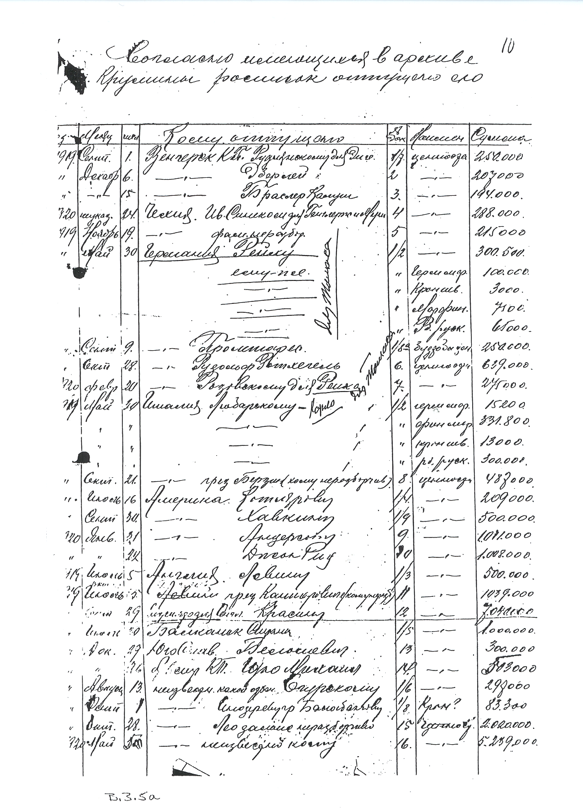
Document 14b
Translation: Comintern accounting sheet of subsidies, in currency and in valuables (gold, jewels), delivered in 1919 and 1920 to Communist parties in Europe and the United States
********************************************************************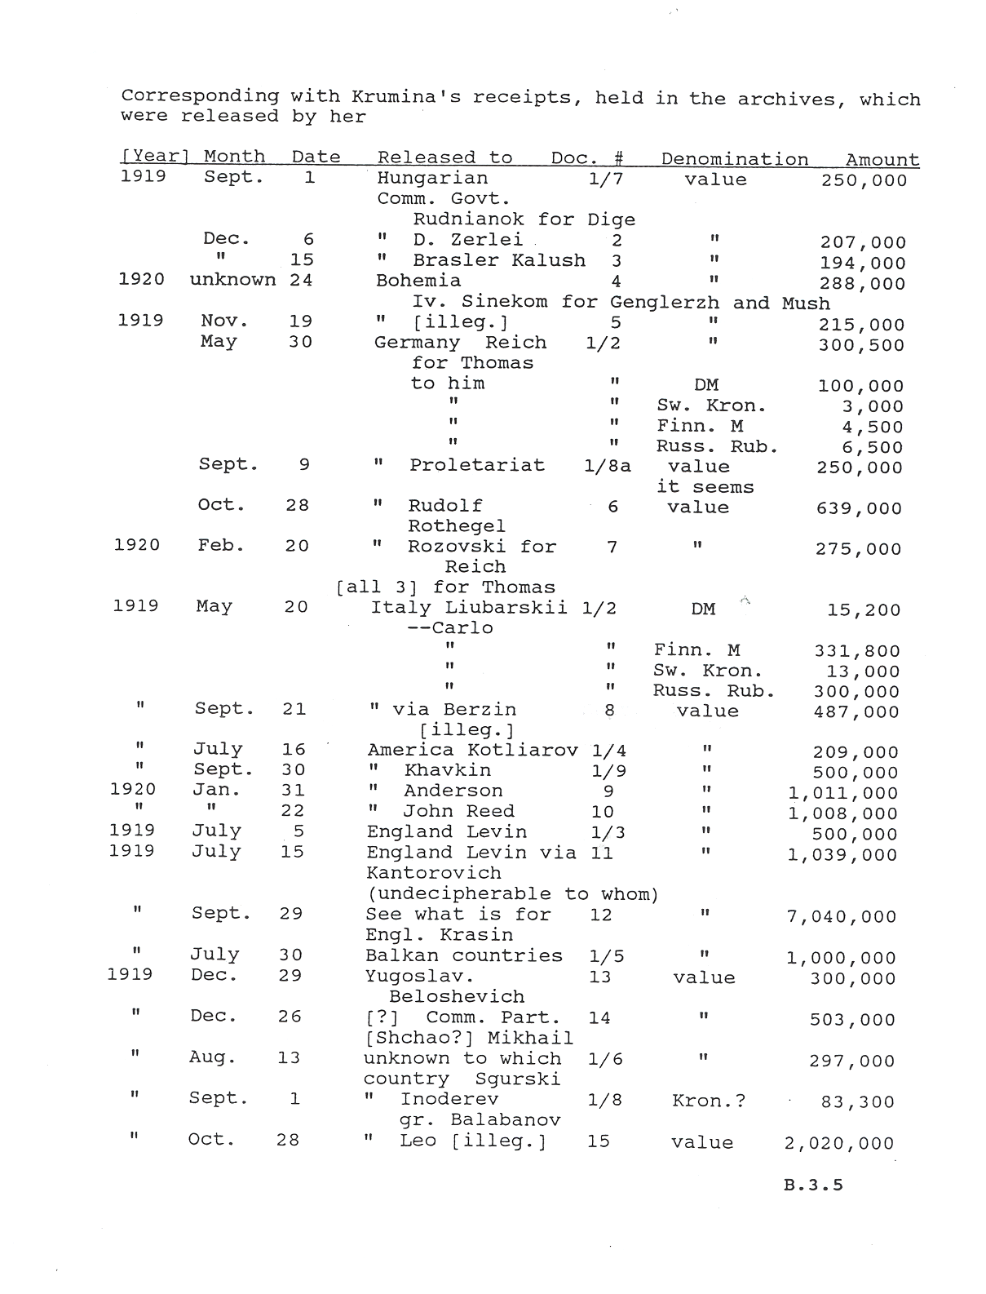

Document 15
Deciphered telegram American Communist Party to the Comintern, 1925, complaining of slow delivery of secret Comintern subsidies by Armand Hammer. RGASPI Moscow 515-1-422 (I)
************************************************************************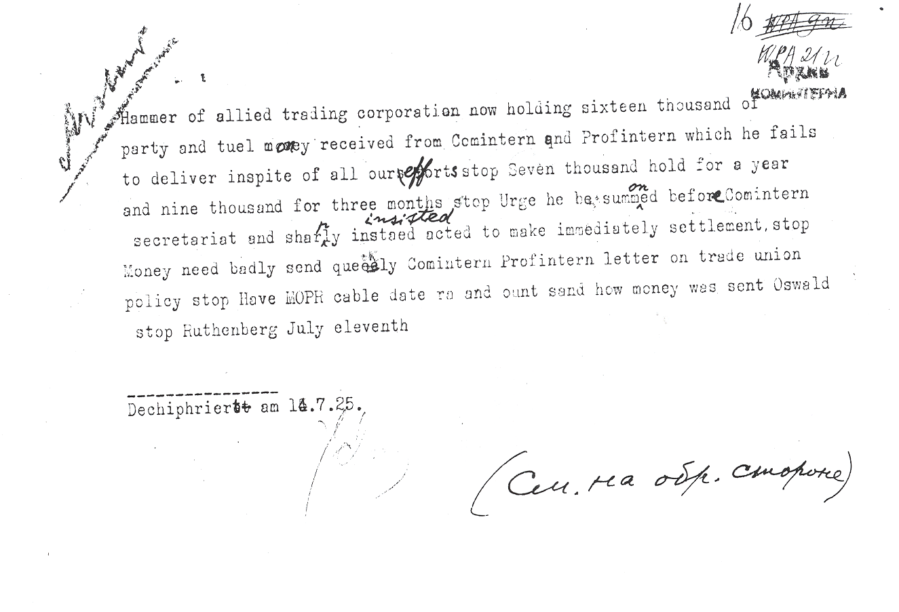

Document 16a
Communist Party of the Soviet Union 1973 accounting sheet for subsidies to foreign Communist parties. Volkogonov Papers.
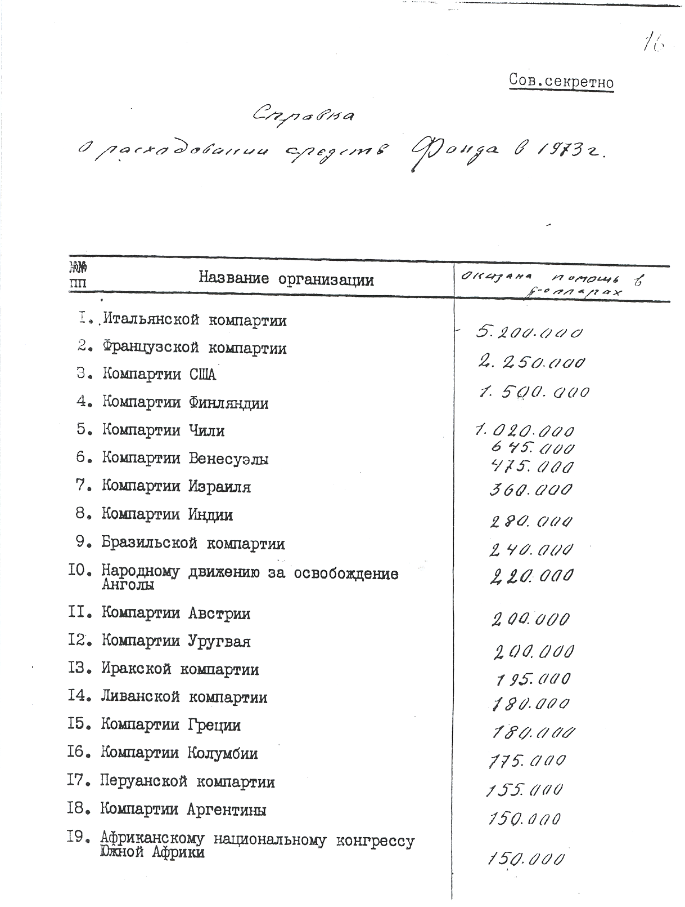
Document 16b
Translation: Communist Party of the Soviet Union 1973 accounting sheet for subsidies to foreign Communist parties. Volkogonov Papers.
***************************************************************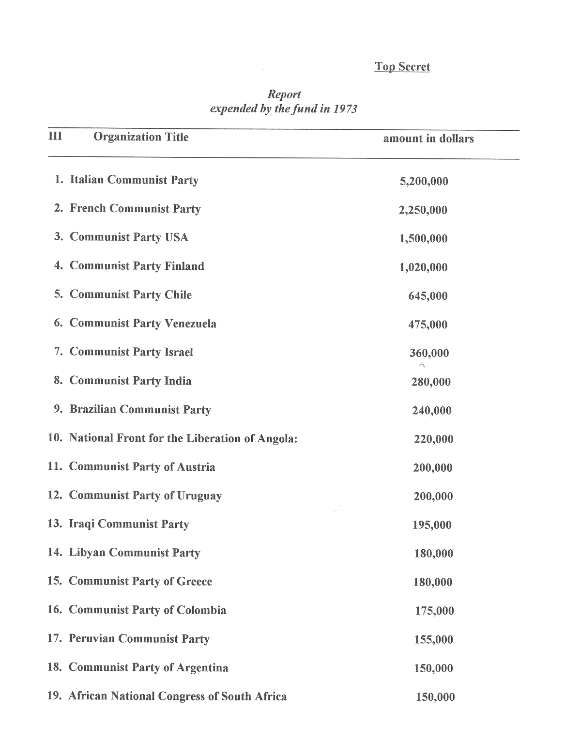
Document 17
First page of a six page 1929 report by a CPUSA organizer on persuading striking white textile workers in Gastonia, NC, to actively include black workers. RGASPI Moscow 515-1-1662
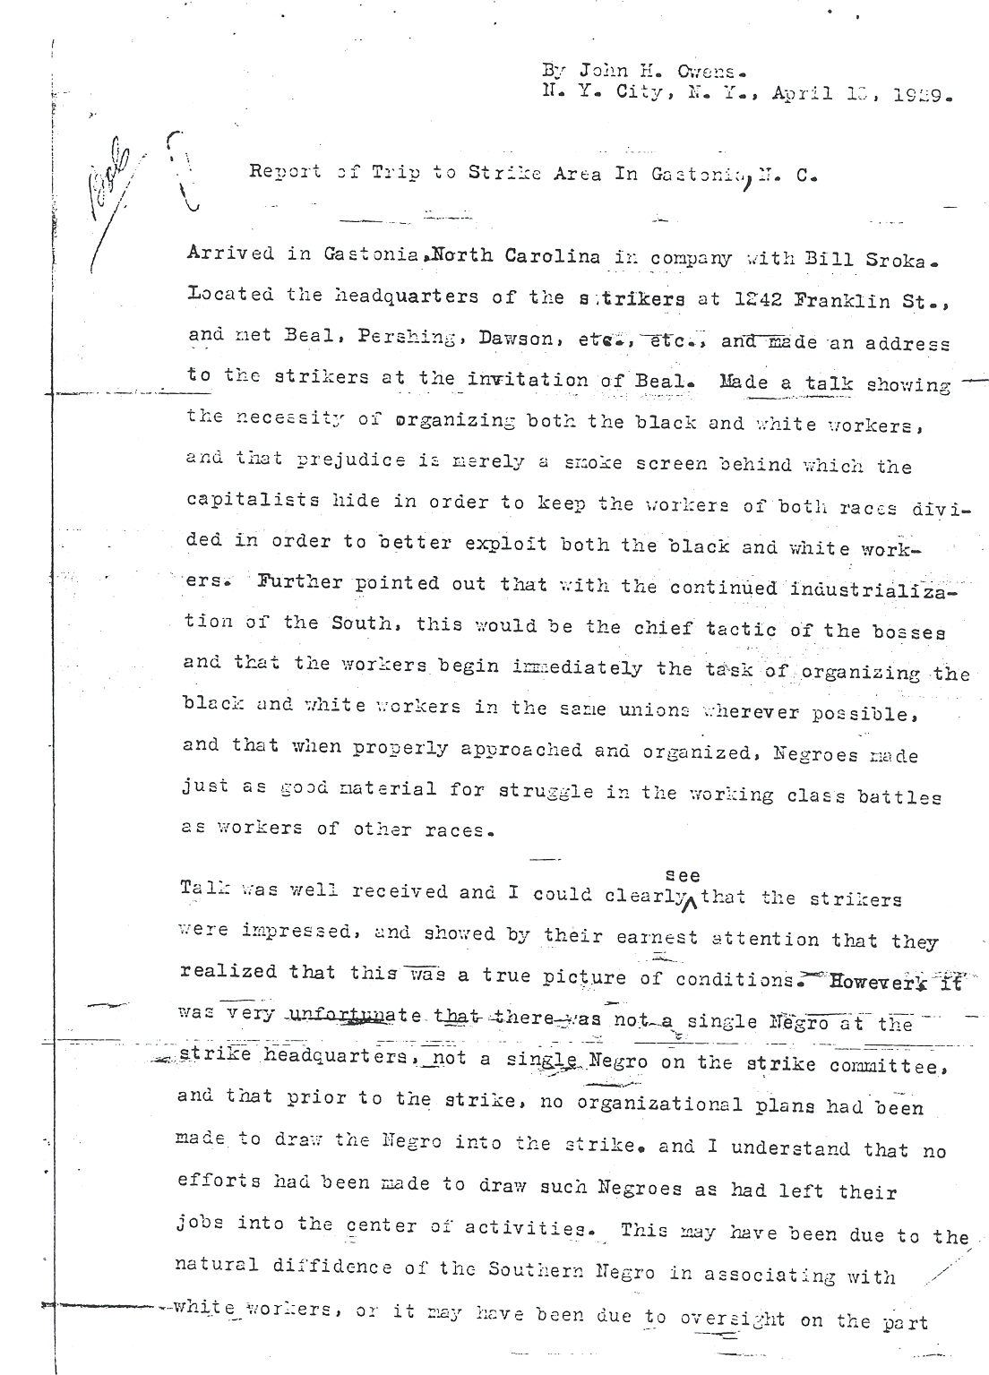

Document 18a
Page one of a report by the CPUSA representative to the Comintern on the work of the CPUSA in the new Congress of Industrial Organizations (CIO). RGASPI Moscow 515-1-3967
***********************************************************************
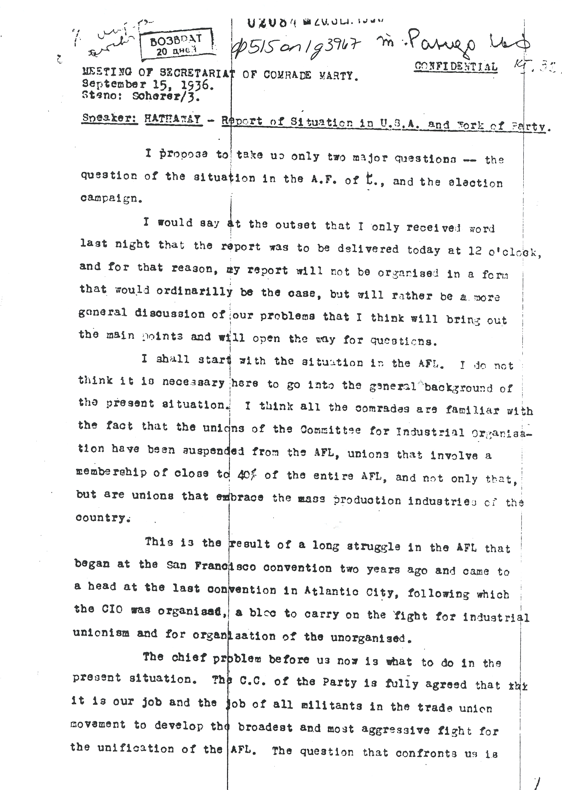
Document 18b
Page seventeen of a report by the CPUSA representative to the Comintern on the work of the CPUSA in the new Congress of Industrial Organizations (CIO). RGASPI Moscow 515-1-3967
*****************************************************************************
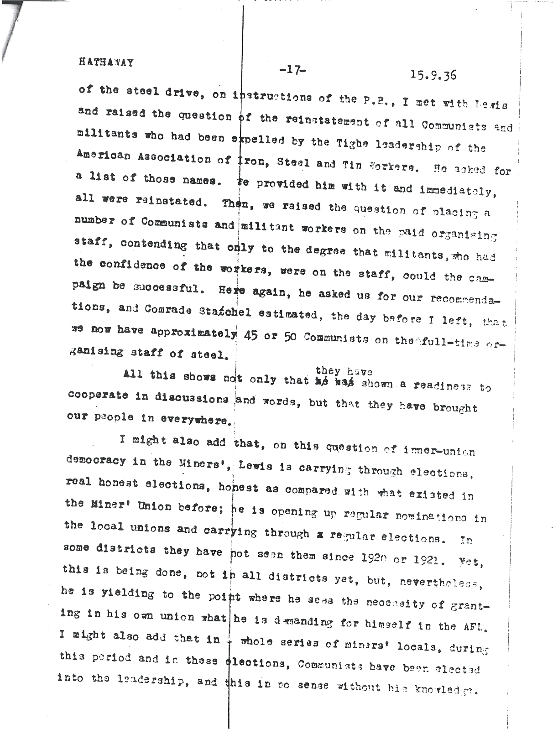
Document 19a
Comintern biographical sketches of members of the CPUSA central committee in 1938, including secret members giving both pseudonyms and real names, including that of Harry Bridges, head of the ILWU, RGASPI Moscow 495-74-467
*********************************************************************
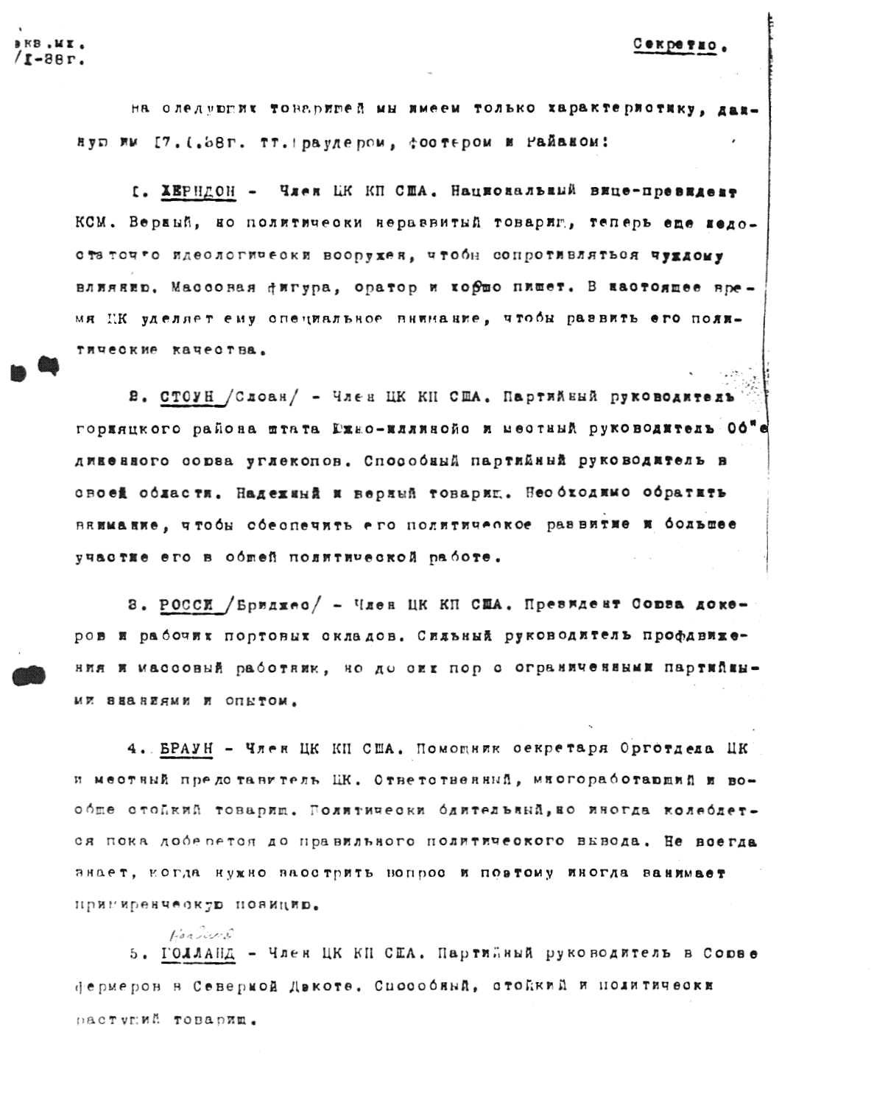
Document 19b
Translation of Harry Bridges section of Comintern biographical sketches of members of the CPUSA central committee in 1938, including secret members giving both his pseudonym, Rossi, and real name, Bridges, RGASPI Moscow 495-74-467
*********************************************************************
3 copies m.kh. Secret
31 January 1938

For the following combrdes, we have only the reviews given 17 January 1938 by Comrades Browder, Foster and Ryan:

1……………………

3. ROSSI / Bridges/ CP USA Central Committee member. President of the Dockers’ and Port Warehouse Workers’ Union. He is a strong leader in the trade union movement an a mass worker, but up till now has only domestic party knowledge and experience.

4………………….
Document 20
Minutes of CPUSA District Bureau (Detroit and Michigan) regarding implementing the CPUSA stance toward effort to organize a national labor party. RGASPI Moscow 515-1-4015
************************************************************************
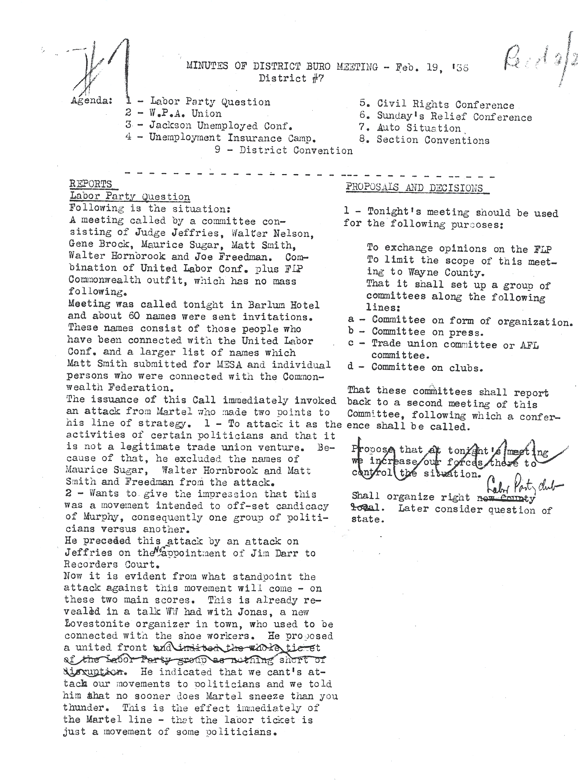
Document 21
First page of internal report of the CPUSA’s ruling Political Bureau praising President Roosevelt's January 1939 address to the U.S. Congress calling for international resistance to Nazi aggression and increased American defense preparation. RGASPI Moscow 495-14-117
*****************************************************************************
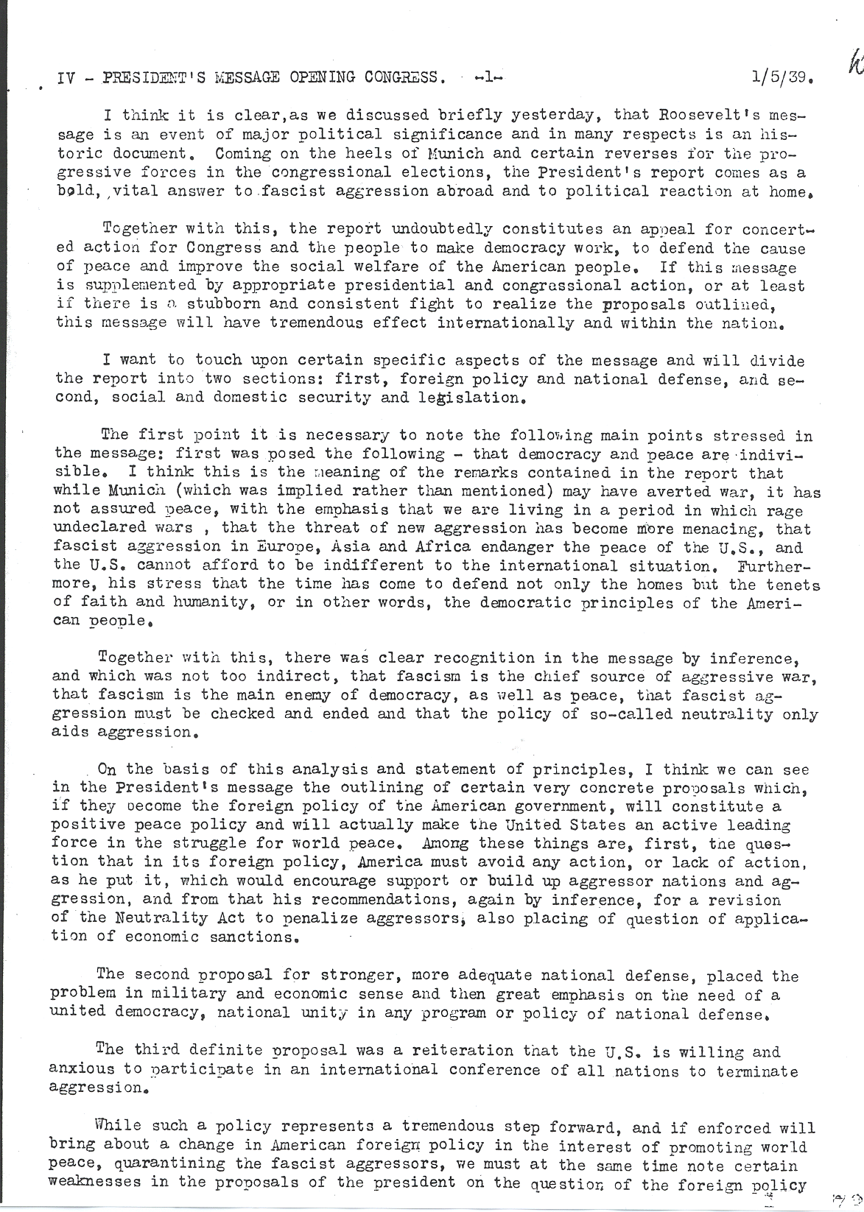
Document 22
Transcription of part of a Dimitrov (Comintern) to Browder (CPUSA) coded message correcting CPUSA interpretation of the Nazi-Soviet Pact of September 1939. RGASPI Moscow 495-74-469
******************************************************************************
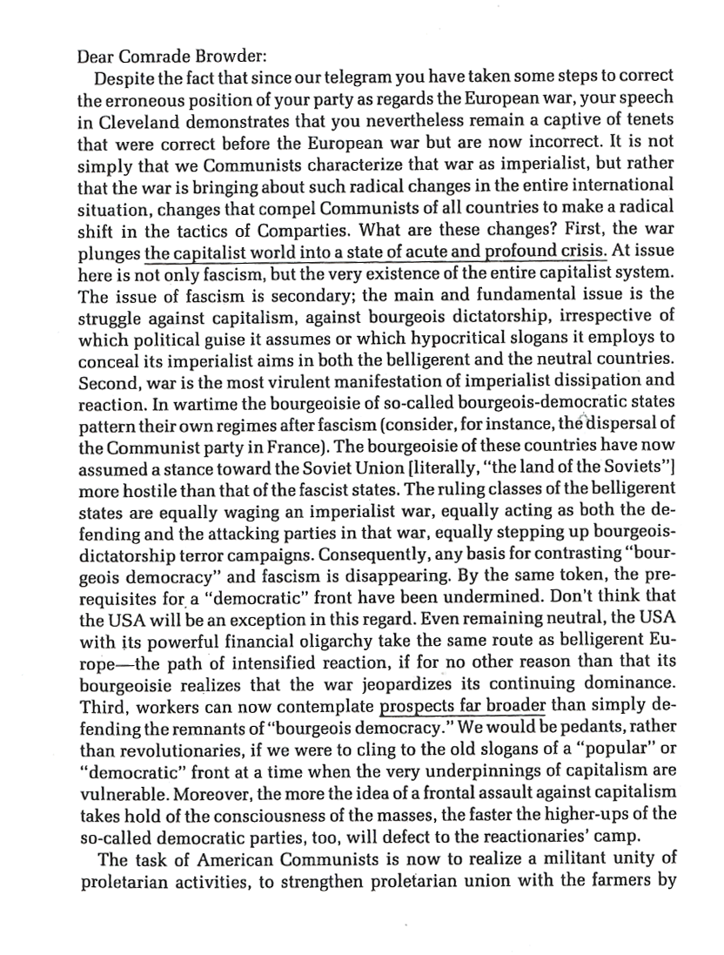
Document 23
One page from eighty-five page CPUSA report to Moscow, April 1941, on the CPUSA's work in opposition to President Roosevelt's program of providing assistance to Great Britain and other nations fighting Nazi Germany. RGASPI Moscow 515-1-4091
******************************************************************************
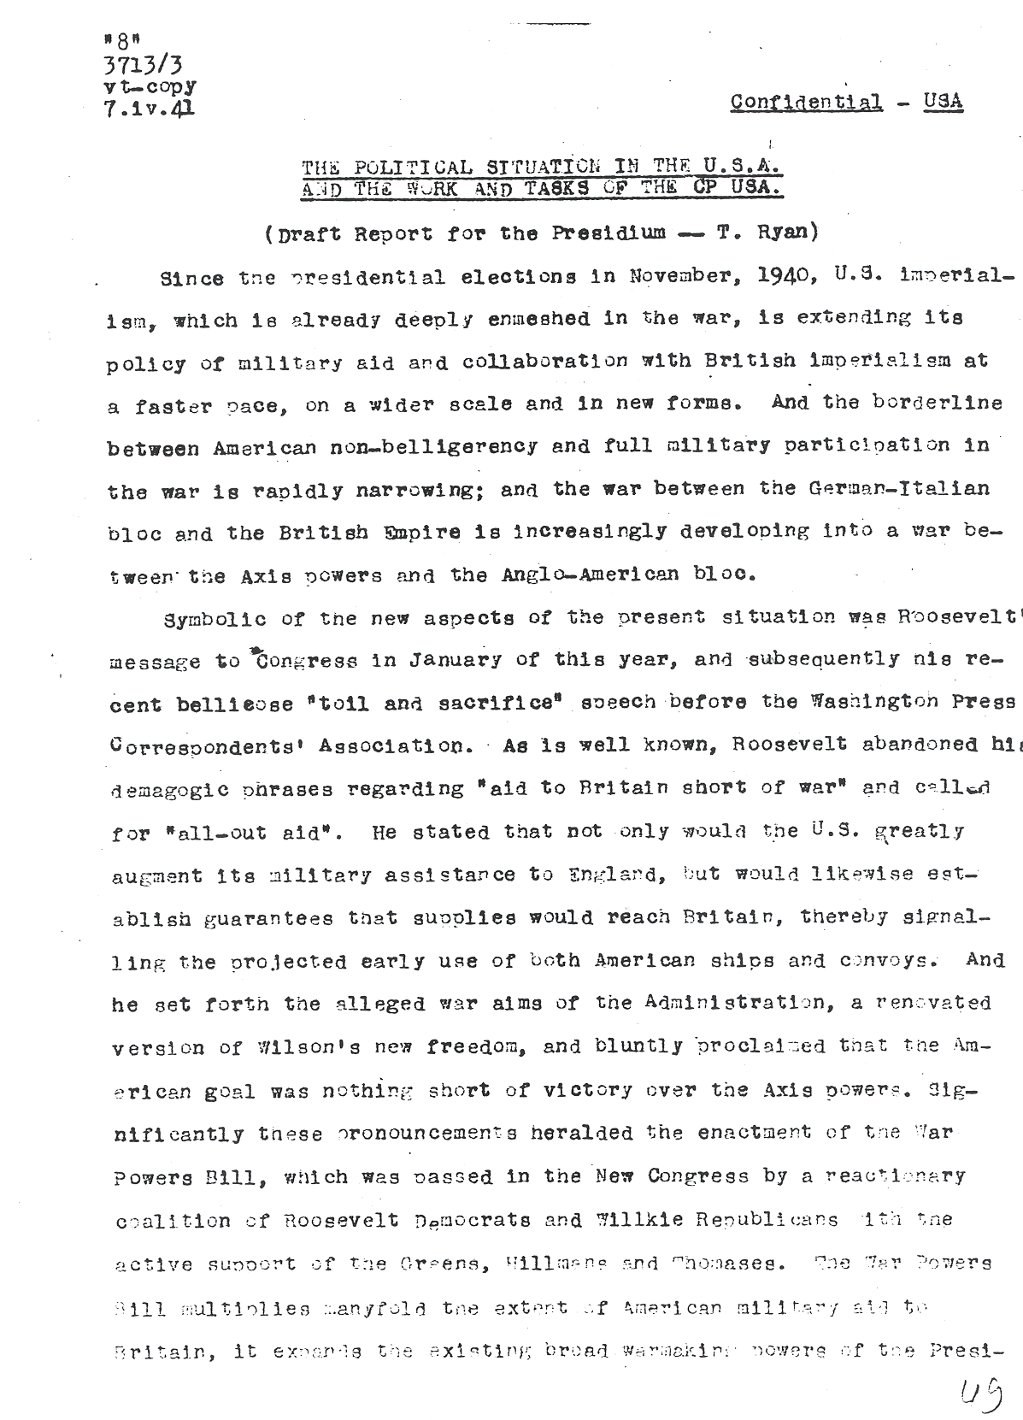

Document 24
Excerpts copied by a CPUSA source in the U.S. State Department from correspondence between the U.S. Ambassador to France and the Assistant Secretary of State. The material, from the late fall of 1936, is marked as reaching Moscow in January of 1937. RGASPI Moscow 515-1-4077
******************************************************************************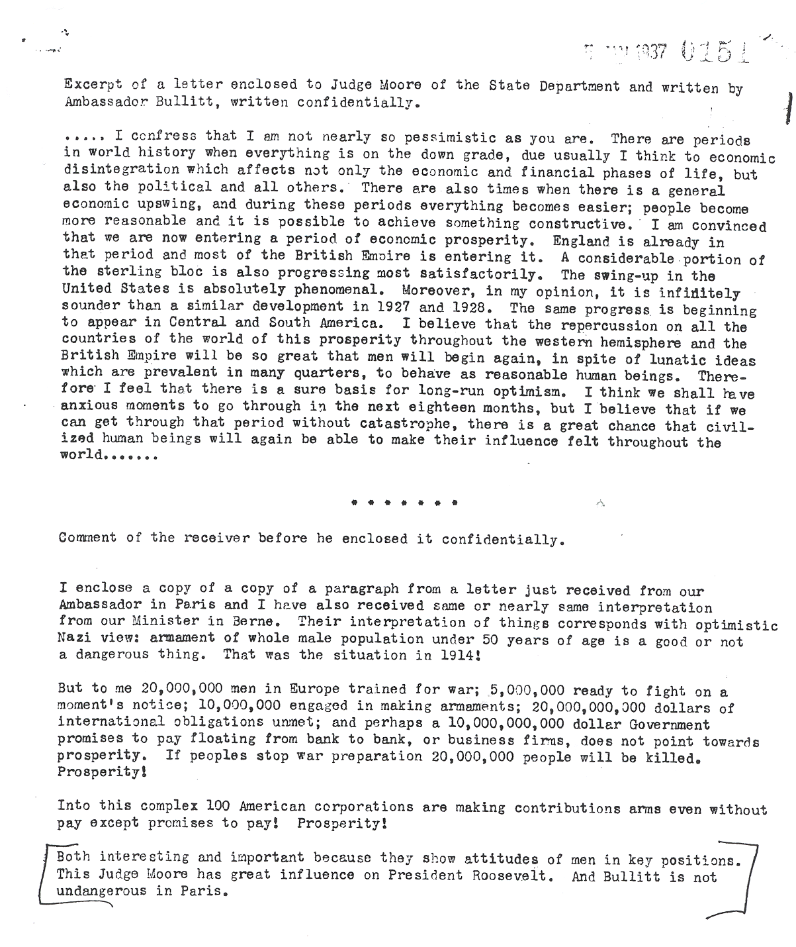

Document 25
Browder (chief of the CPUSA) to Dimitrov (chief of the Comintern), 1938, on his sister’s work for Soviet intelligence. KGB archive
*****************************************************************************
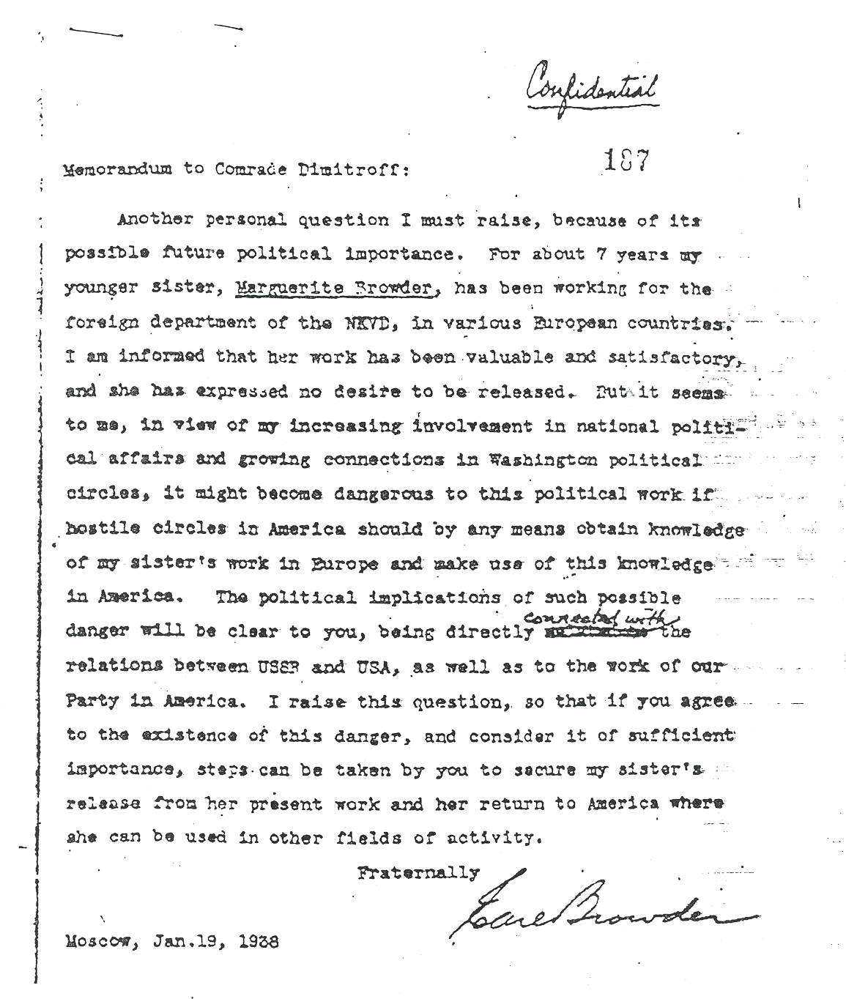
Document 26
Translation of a 1940 cover note of Beria (KGB) to Dimitrov (Comintern) transmitting a message from Browder (CPUSA) conveying an offer of service to the USSR from a leading French politician then in exile. RGASPI Moscow 495-74-478
******************************************************************************
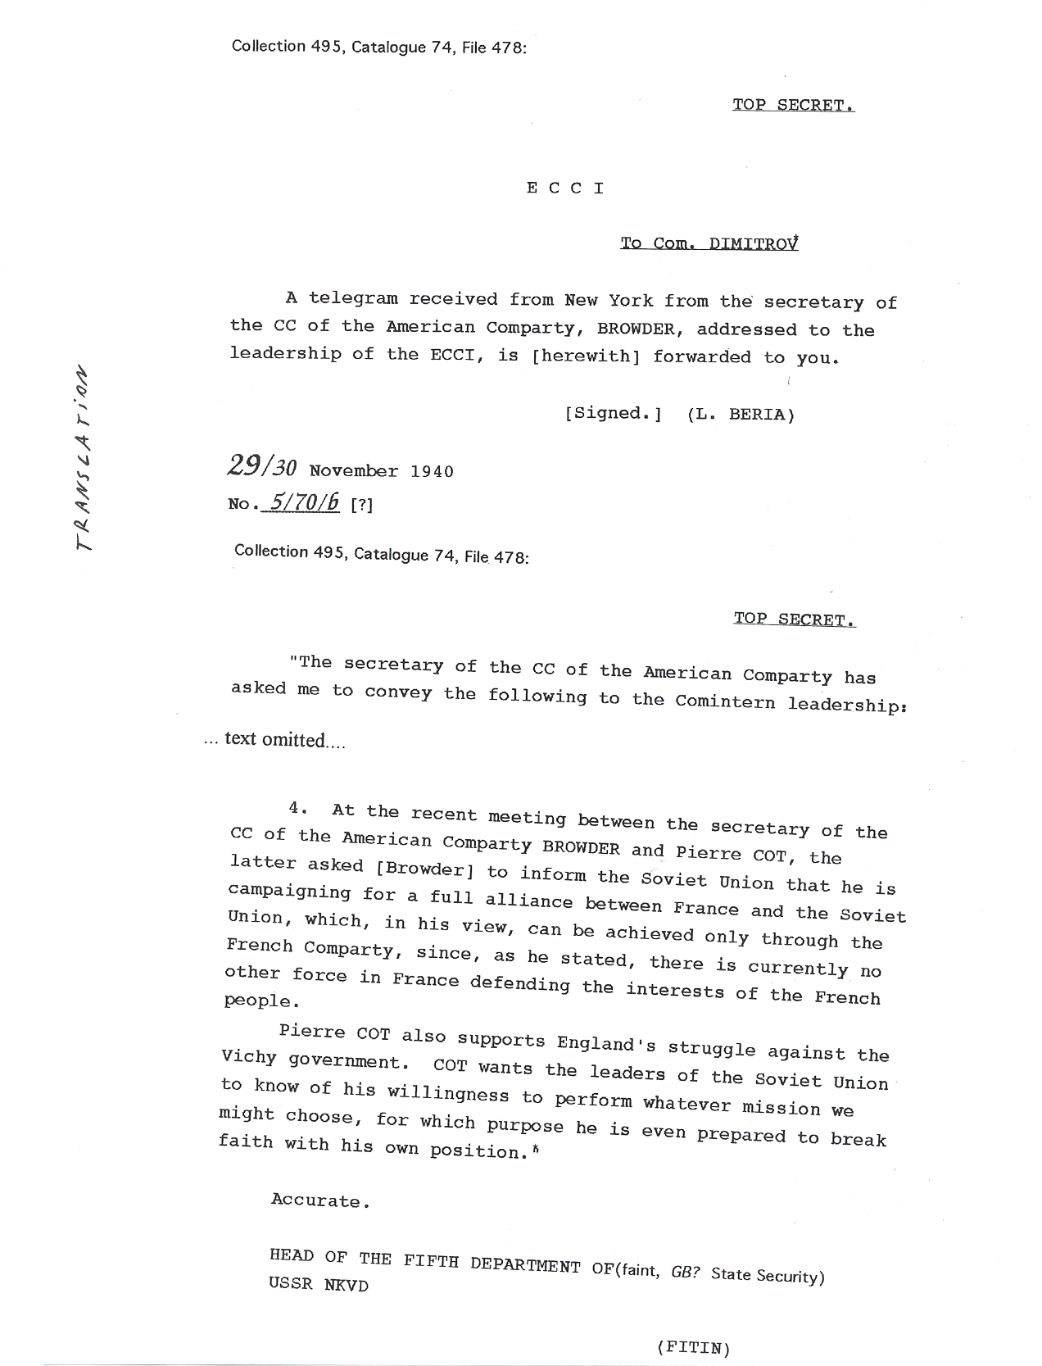
Document 27
Decrypted message (cablegram), 1942, Moscow KGB headquarter to New York KGB station regarding the "signing on" of Pierre Cot, U.S. National Security Agency (NSA) Venona Project
****************************************************************************
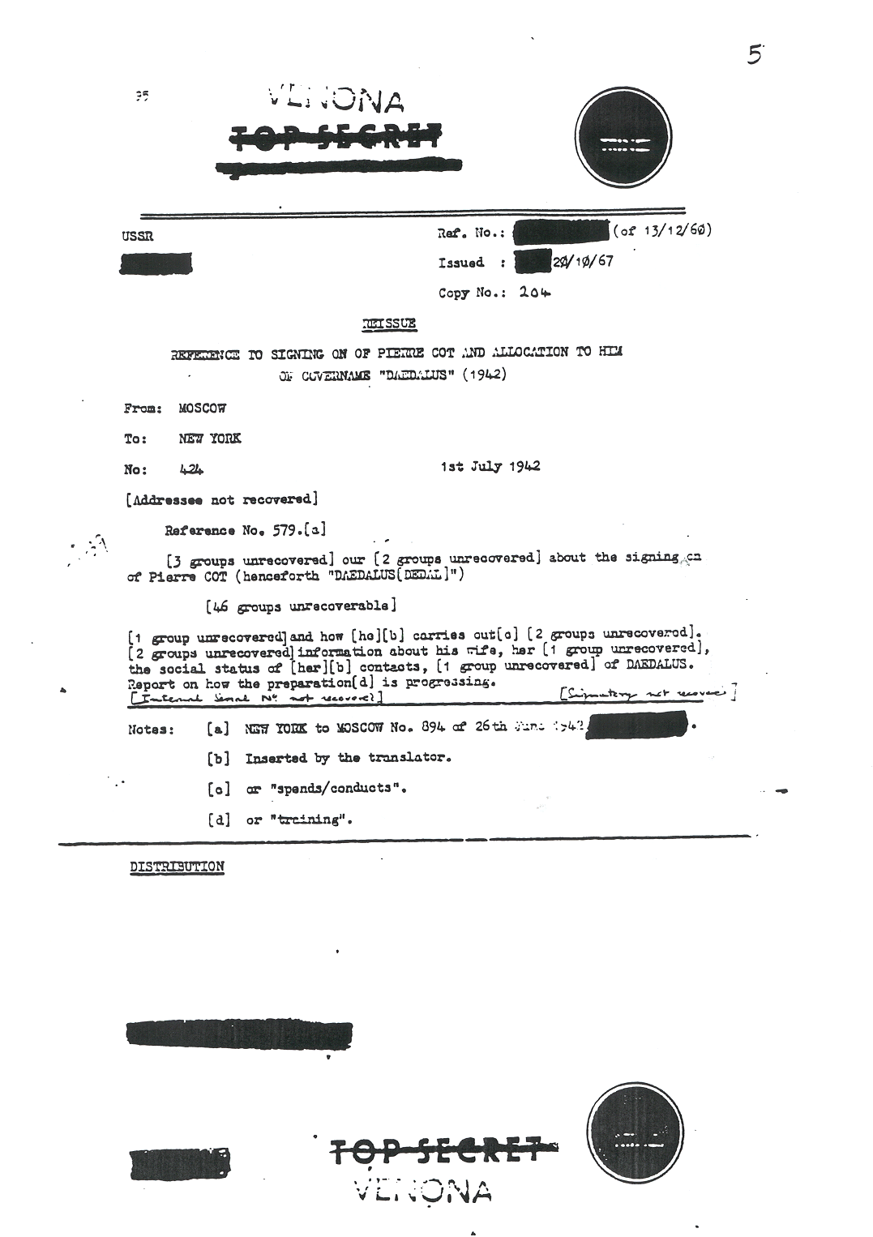
Document 28
Decrypted message, New York KGB station to Moscow HQ, 1944, regarding Elizabeth Bentley and Victor Perlo’s CPUSA-based espionage apparatus. NSA Venona Project Records
*****************************************************************************
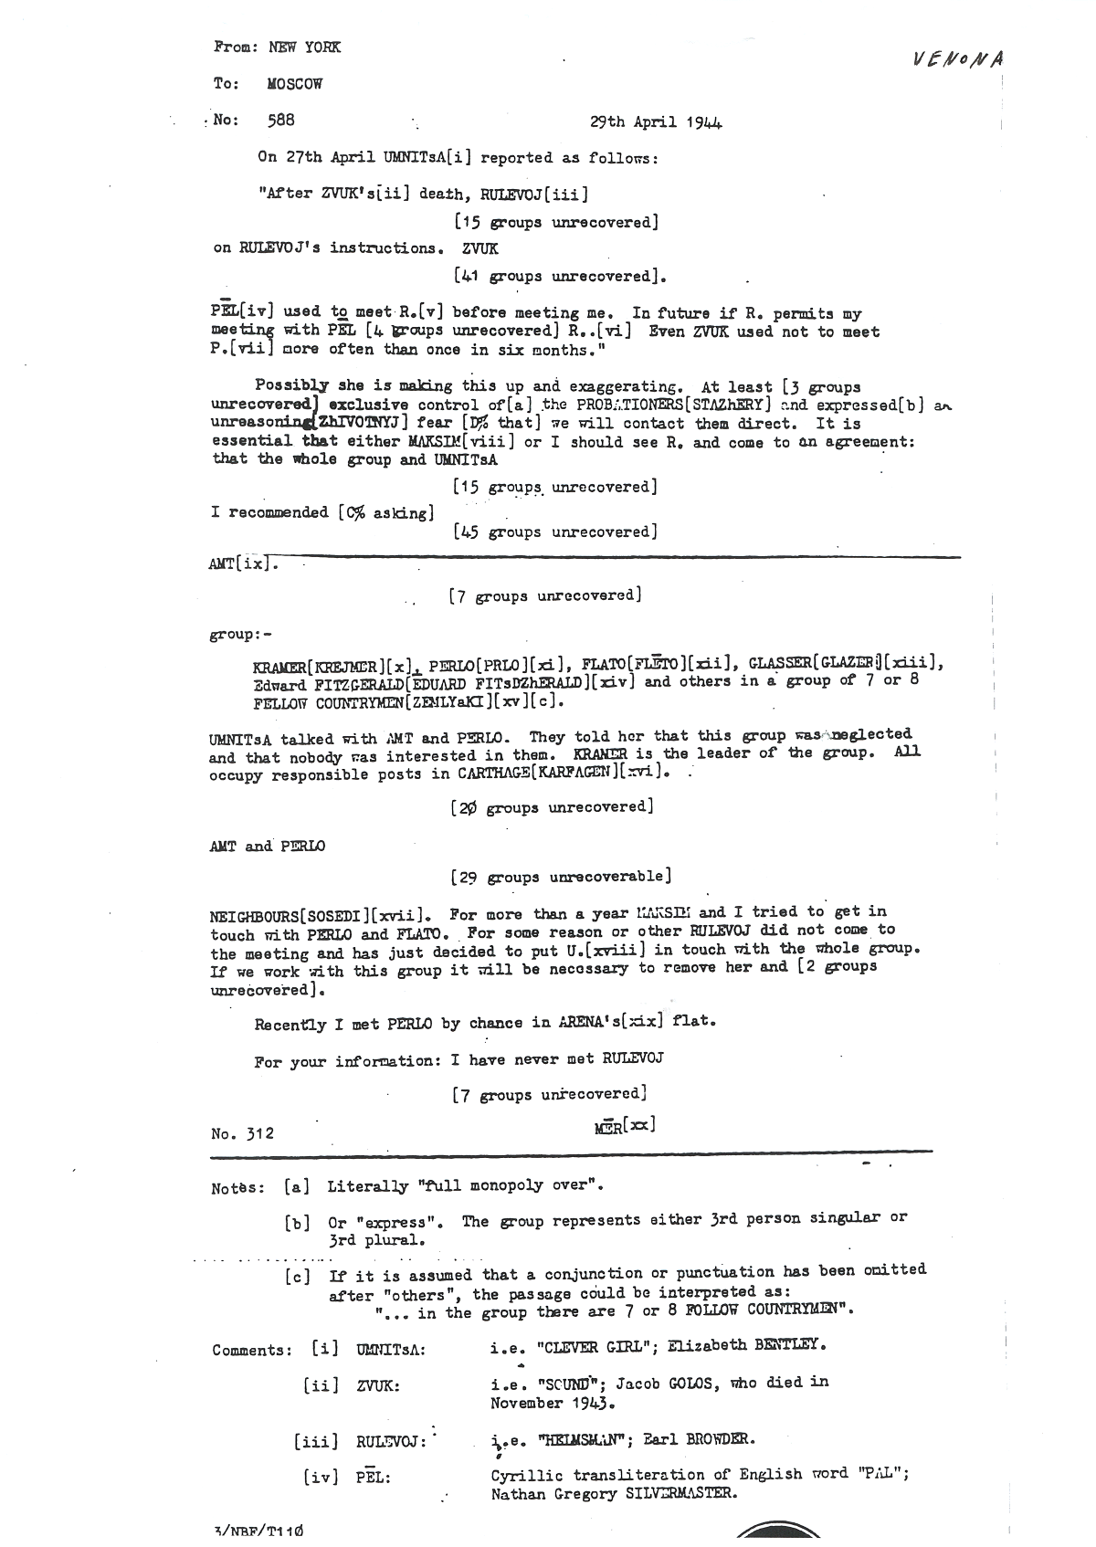
Document 29
Translation of Fitin (KGB) to Dimitrov (Comintern) message, 1944, regarding members of the Perlo apparatus. RGASPI Moscow 495-74-485
******************************************************************************
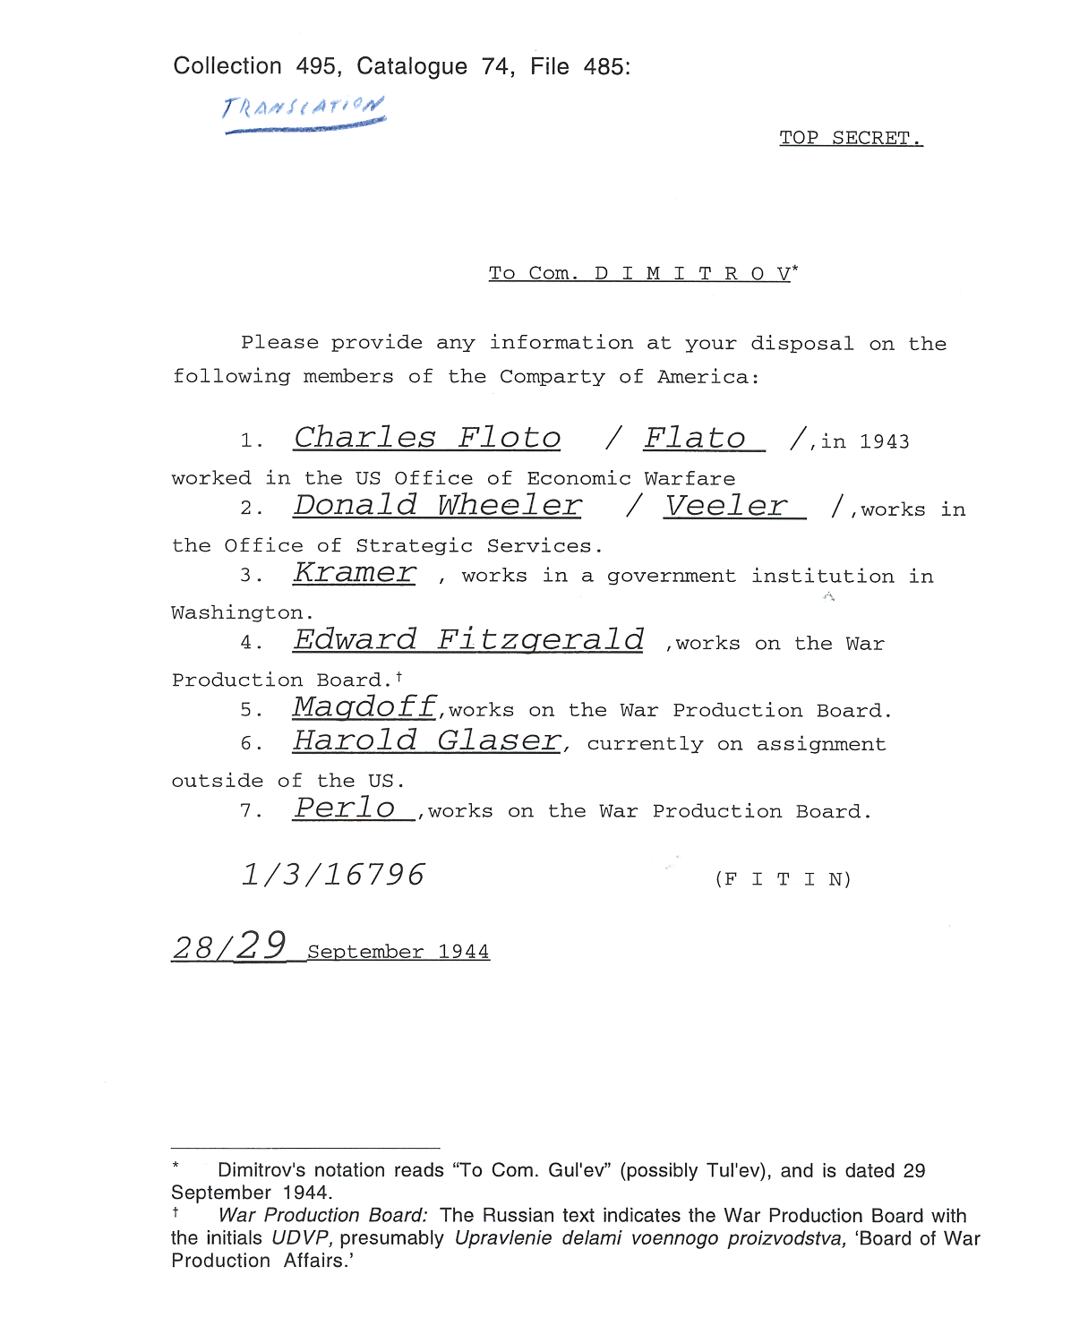
Document 30
NSA Venona Project Records
******************************************************************************
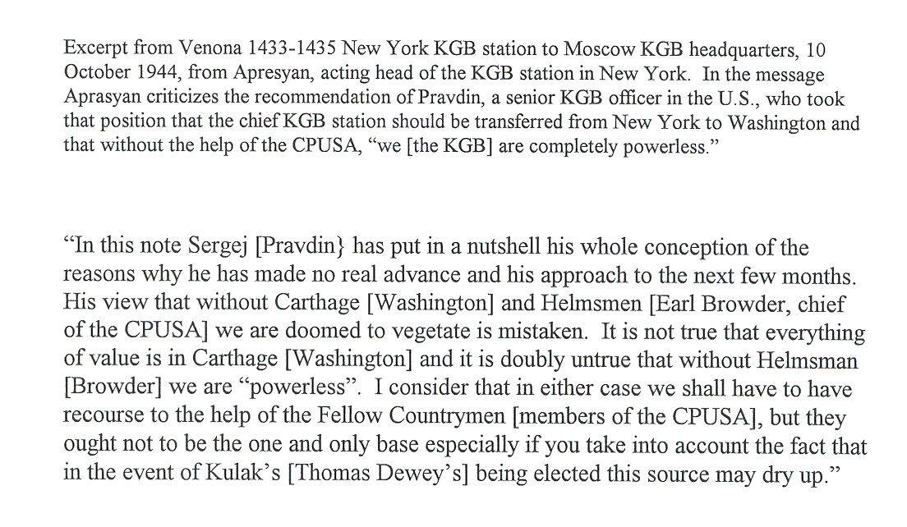
Document 31
Decrypted message, New York KGB station to Moscow, Venona 1557, 27 November 1944, regarding Julius and Ethel Rosenberg and other sources. NSA Venona Project Records
**********************************************************************
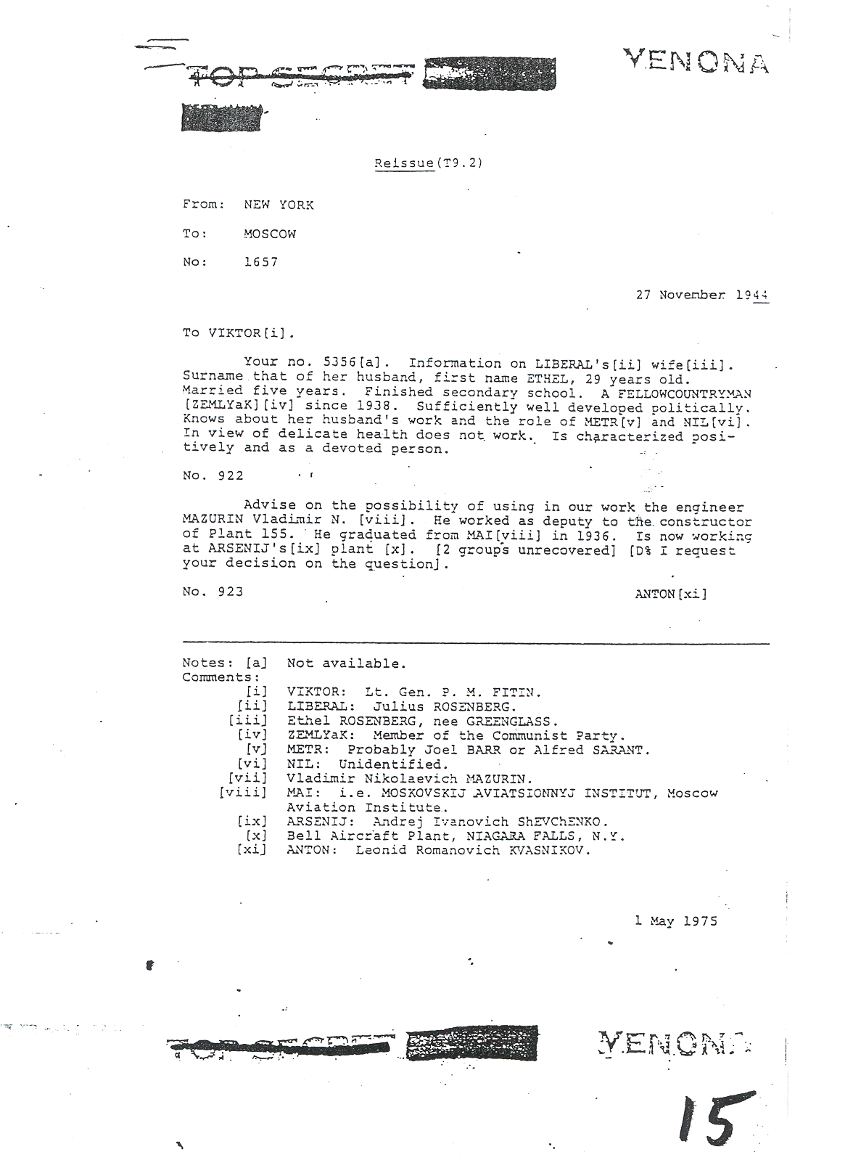
Document 32a
One part of decrypted message Venona 1119 1121 KGB New York to Moscow, 4-5 August 1944. KGB officer reports meeting with Harry White, Assistant Secretary of the Treasury (JURIST), and the information White provided. NSA Venona Project Records
**********************************************************************
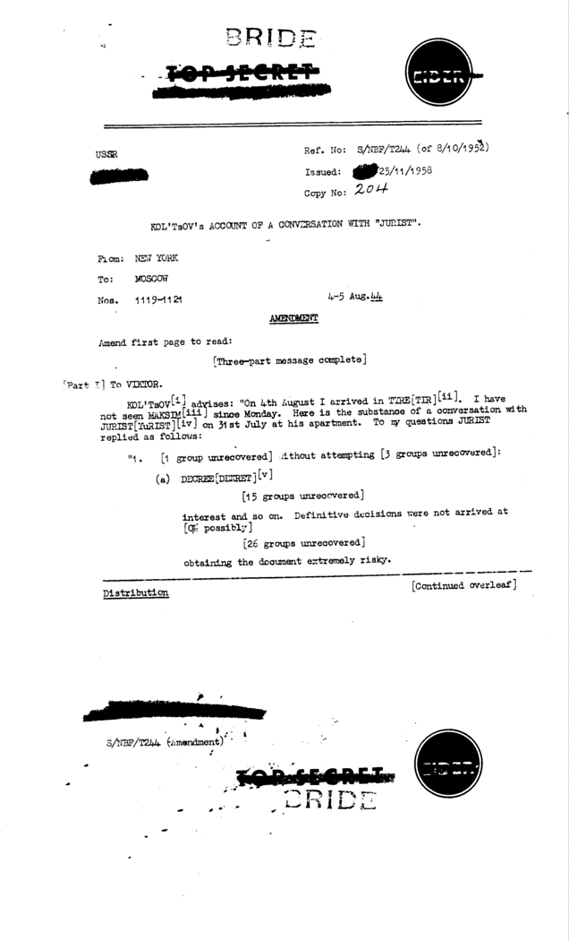

Document 32b
Second part of a decrypted message, Venona 1119 1121 KGB New York to Moscow, 4-5 August 1944. KGB officer reports on meeting with Harry White (JURIST), and White’s eagerness to assist the KGB despite the risks. NSA Venona Project Records
**********************************************************************
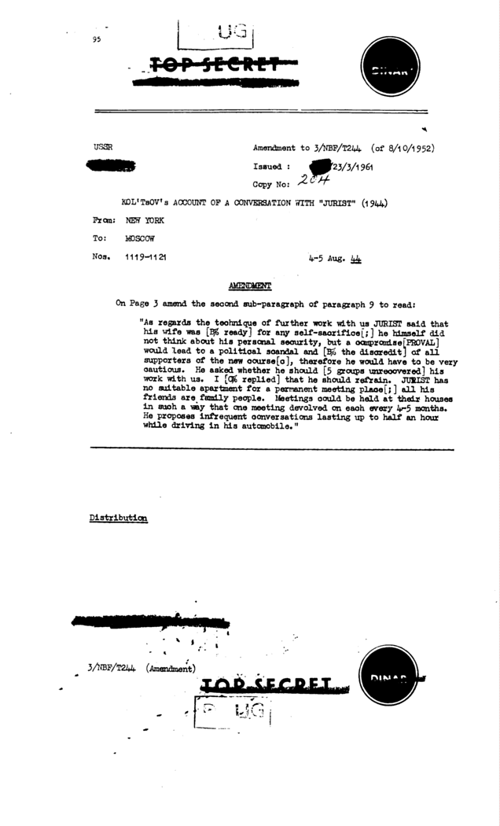
Document 33
Decrypted message, Venona 1585 KGB New York to Moscow, 12 November 1944. Meeting of KGB agent with Harvard physicist Theodore Hall and Hall volunteering to assist the KGB by reporting on his work at Los Alamos. NSA Venona Project Records
****************************************************************************
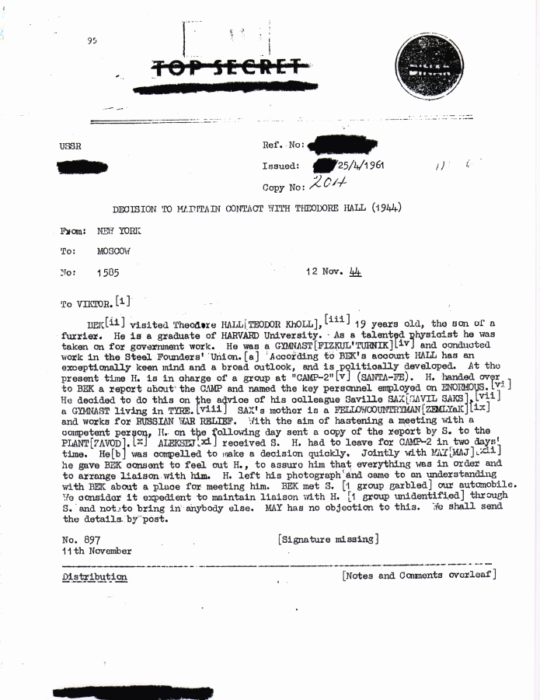
Document 34
Decrypted message, Venona 1585 KGB New York to Moscow, 12 November 1944. Meeting of KGB agent with Harvard physicist Theodore Hall and Hall volunteering to assist the KGB by reporting on his work at Los Alamos. NSA Venona Project Records
****************************************************************************
Document 35
Decrypted message, Venona 1822 KGB Washington to KGB Moscow, 30 March 1945, on meeting of KGB officer with a GRU source, Ales (Alger Hiss). NSA Venona Project Records
****************************************************************************


